10.2.3 Render - Blender Render Engine - Lighting
Lighting 3
Viewing Restrictions 3
Global Influences 3
Lighting Settings 4
Lighting in the Workflow 4
Overriding Materials to Reset Lighting 4
Lights 5
Lights Common Options 5
Object Data 6
Preview 6
Light Attenuation 6
Description 7
Falloff types 7
Lin/Quad Weighted 7
Linear 7
Quadratic 8
Mixing “Linear” and “Quad” 9
Zeroing both “Linear” and “Quad” 9
Graphical Summary 9
Custom Curve 10
Inverse Square 12
Inverse Linear 13
Constant 13
Sphere 14
Examples 15
Distance Example 15
Inverse Square Example 15
Sphere Example 16
Lamps Textures 17
Options 19
What the Light Affects 19
Lamps Related Settings 19
Lighting Groups 20
Materials 20
Render Layers 21
See Also 21
Shadows 21
Lamps: Ray-traced Shadows 22
Lamps: Buffered Shadows 23
Common Shadowing Lamps Options 24
See Also 25
Lamps Raytraced Shadows 25
What is Quasi-Monte Carlo? 28
Volumetric Lighting 28
See also 29
Lamps 29
Point 30
Lamp Options 30
Shadows 30
Raytraced Shadows 31
Spot 31
Lamp options 32
Shadows 33
Spot Shape 33
Raytraced Shadows 35
Spot Buffered Shadows 35
Shadow Buffer Types 36
“Classical” and “Classic-Halfway” 37
“Irregular” 39
Deep generation method 40
Common options 40
Hints 42
Spot Volumetric Effects 42
See Also 43
Area 43
Lamp options 43
Shadows 44
Area Shape 44
Area Raytraced Shadows 45
Shadow Samples 45
Sample Generator Types 45
Technical Details 46
Hints 46
Hemi Lamp 47
Options 47
Sun 48
Lamp options 48
Sky & Atmosphere 49
Shadow 49
Raytraced Shadows 49
Sun: Sky & Atmosphere 50
Options 51
Sky 51
Atmosphere 52
Examples 53
Sky 54
Atmosphere 57
Hints and limitations 59
Lighting Rigs 59
Environment or Ambient Only 60
Single Rig 61
Two-Point Rig 61
Three-Point Rigs 62
Studio rig 62
Standard Rig 63
Four-point Rig 64
Troubleshooting 64
Environment Lighting 65
Ambient Occlusion 66
Options 66
Gather 67
Raytrace 67
Approximate 69
Common Settings 70
Technical Details 70
Hints 70
Indirect Lighting 70
Options 73
Approximate 73
Exposure and Range 73
Description 74
Options 74
Examples 74
Hints 75

Lighting

Lighting is a very important topic in rendering, standing equal to modeling, materials and textures. The most accurately modeled and textured scene will yield poor results without a proper lighting scheme, while a simple model can become very realistic if skillfully lit.

Viewing Restrictions
The color of an object and the lighting of your scene is affected by:
- Your ability to see different colors (partial color blindness is common).
- The medium in which you are viewing the image (e.g. an LCD panel versus printed glossy paper).
- The quality of the image (e.g. a JPEG at 0.4 compression versus 1.0).
- The environment in which you are viewing the image (e.g. a CRT monitor with glare versus in a dark room, or in a sunshiny blue room).
- Your brain’s perception of the color and intensity relative to those objects around it and the world background color, which can be changed using color manipulation techniques using Bforartists Composite Nodes.

Global Influences
In Bforartists, the elements under your control which affect lighting are:
- The color of the world ambient light.
- The use of Ambient Occlusion as a way to cast that ambient light onto the object.
- The degree to which the ambient light colors the material of the object.
- The use of Indirect lighting, where the color of one object radiates onto another.
- The lamps in your scene.
The physics of light bouncing around in the real world is simulated by Ambient Occlusion (a world setting), buffer shadows (which approximate shadows being cast by objects), ray tracing (which traces the path of photons from a light source). Also, within Bforartists you can use Indirect lighting. Ray tracing, ambient occlusion, and indirect lighting are computer-intensive processes. Bforartists can perform much faster rendering with its internal scan line renderer, which is a very good scan line renderer indeed. This kind of rendering engine is much faster since it does not try to simulate the real behavior of light, assuming many simplifying hypotheses.

Lighting Settings
Only after the above global influences have been considered, do you start adding light from lamps in your scene. The main things under your control are the:
- Type of light used (Sun, Spot, Lamp, Hemi, etc.).
- Color of the light.
- Position of the light and its direction.
- Settings for the light, including energy and falloff.
Then you are back to how that material’s shader reacts to the light.
This chapter attempts to address the above, including how lights can work together in rigs to light your scene. In this chapter we will analyze the different type of lights in Bforartists and their behavior; we will discuss their strong and weak points. We also describe many lighting rigs, including the ever-popular three-point light method.

Lighting in the Workflow
In this user manual we have placed Lighting before Materials; you should set up your lighting before assigning materials to your meshes. Since the material shaders react to light, without proper lighting, the material shaders will not look right, and you will end up fighting the shader, when it is really the bad lighting that is causing you grief. All of the example images in this section do not use any material setting at all on the ball, cube or background.

Overriding Materials to Reset Lighting
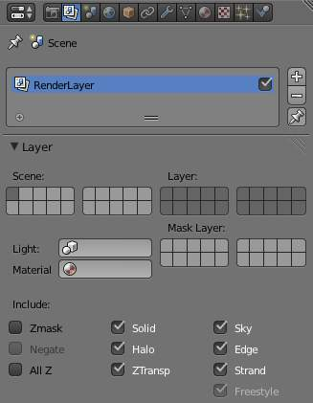
Material field in the Render Layers panel
If you have started down the road of assigning materials, and are now fiddling with the lighting, we suggest that you create a default, generic gray material–no Vertex Color, no Face Texture, no Shadeless, just plain old middle gray with RGB of (0.8, 0.8, 0.8). Name this Gray.
Next go to the Render context. In the Render Layers panel, select your new Gray material in the Material field. This will override any materials you may have set, and render everything with this color. Using this material, you can now go about adjusting the lighting. Just empty this field to get back to your original materials.

Lights

As previously stated, there are multiple types of lighting in Bforartists, like indirect light or ambient light. However, one of the most used are “lights”, or “lamps”. In this section, we will discuss general info and settings for these lights (you will find more lamp-specific details in the Lamps section):
- Light Properties - settings common to all lamps.
- Light Attenuation.
- Textures - how to apply texture(s) to lamps.
- What Light Affects.
- Lights In Other Contexts - lamp-related setting in other contexts.

Lights Common Options

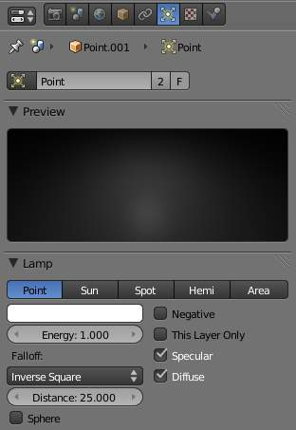
Lamp Properties panels
There are five types of lamps in Bforartists. They share all or some of the options listed here:

Object Data
Browse Light Object Data
Click to view all lights in the current scene.
Name
The name of the currently selected light object data. Edit to change the name.
Number of Users
The number of light objects sharing the light object data.
F
Create a fake user for this object data.

Preview
A quick preview of the light settings.
Lamp

Distance
The Dist field indicates the number of Bforartists Units (BU) at which the intensity of the current light source will be half of its intensity. Objects less than the number of BU away from the lamp will get more light, while objects further away will receive less light. Certain settings and lamp falloff types affect how the Distance field is interpreted, meaning that it will not always react the same; see the page about light falloff.
- The Sun and Hemi Lamps are another class of Lamps which uses a constant falloff. Those lamps don’t have a Dist field, and are often called “Base Lighting Lamps”.
Energy
The intensity of the light source’s illumination (from 0.0 to 10.0).
Color
The color of the light source’s illumination. Opens a color swatch.
Negative
Let the lamp cast negative light.
This Layer Only
The Lamp only illuminates objects on the same layer the lamp is on.
Specular
The Lamp creates specular highlights.
Diffuse
The Lamp does diffuse shading.

Light Attenuation

Description
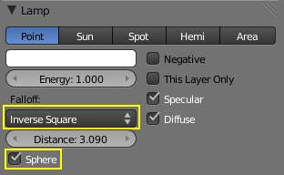
Lamp panel, falloff options highlighted
There are two main controls for light falloff for Point and Spot lamps.
- The lamp Falloff type drop-down list, and
- The Sphere button.

Falloff types

Lin/Quad Weighted
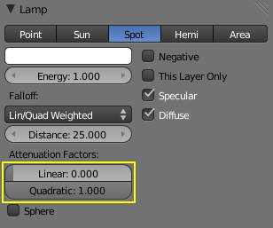
Lamp panel with Lin/Quad Weighted Falloff options highlighted
When this setting is chosen, two sliders are shown, Linear and Quadratic, which control respectively the “linearness” and “quadraticness” of the falloff curve.
This lamp falloff type is in effect allowing the mixing of the two light attenuation profiles (linear and quadratic attenuation types).

Linear
This slider input field can have a value between 0.0 and 1.0. A value of 1.0 in the Linear field and 0.0 in the Quadratic field in effect means that the light from this source is completely linear. This means that at the number of Bforartists Units distance specified in the Distance field, this light source’s intensity will be half the value it was originally.
When the Quadratic slider is set to 0.0, the formula for working out the attenuation at a particular range for full linear attenuation is:
I = E × (D / (D + L × r))
Where
- I is the calculated Intensity of light.
- E is the current Energy slider setting.
- D is the current setting of the Dist field.
- L is the current setting of the Linear slider.
- r is the distance from the lamp where the light intensity gets measured.

Quadratic
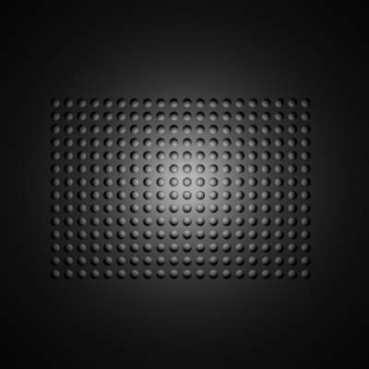
Lamp with Lin/Quad Weighted falloff default settings
This slider input field can have a value between 0.0 and 1.0. A value of 1.0 in the Quadratic field and 0.0 in the Linear field means that the light from this source is completely quadratic.
Quadratic attenuation type lighting is considered a more accurate representation of how light attenuates (in the real world). In fact, fully quadratic attenuation is selected by default for Lin/Quad Weighted lamp fallout (see Lamp with Lin/Quad Weighted falloff default settings).
Here again, the light intensity is half when it reaches the Distance value from the lamp. Comparing the quadratic falloff to the linear falloff, the intensity decays much slower at distances lower than the set Distance, but it attenuates much quicker after Distance is reached.
When the Linear slider is set to 0.0, the formula for working out the attenuation at a particular range for full quadratic attenuation is:
I = E × (D2 / (D2 + Q × r2 ))
Where
- I is the calculated Intensity of light.
- E is the current Energy slider setting.
- D is the current setting of the Dist field.
- Q is the current setting of the Quad slider.
- r is the distance from the lamp where the light intensity gets measured.

Mixing “Linear” and “Quad”
If both the Linear and Quad slider fields have values greater than 0.0, then the formula used to calculate the light attenuation profile changes to this:
I = E × (D / (D + L × r)) × (D2 / (D2 + Q × r2 ))
Where
- I is the calculated Intensity of light.
- E is the current Energy slider setting.
- D is the current setting of the Dist field.
- L is the current setting of the Linear slider.
- Q is the current setting of the Quad slider.
- r is the distance from the lamp where the light intensity gets measured.

Zeroing both “Linear” and “Quad”
If both the Linear and Quadratic sliders have 0.0 as their values, the light intensity will not attenuate with distance. This does not mean that the light will not get darker - it will, but only because the energy the light has is spread out over a wider and wider distance. The total amount of energy in the spread-out light will remain the same, though. The light angle also affects the amount of light you see. It is in fact the behavior of light in the deep space vacuum.
If what you want is a light source that doesn’t attenuate and gives the same amount of light intensity to each area it hits, you need a light with properties like the Constant lamp Falloff type.
Also, when the Linear and Quad sliders are both 0.0 values the Distance field ceases to have any influence on the light attenuation, as shown by the equation above.

Graphical Summary
Below is a graph summarizing the lin/quad attenuation type, showing attenuation with or without the Sphere option (described later).
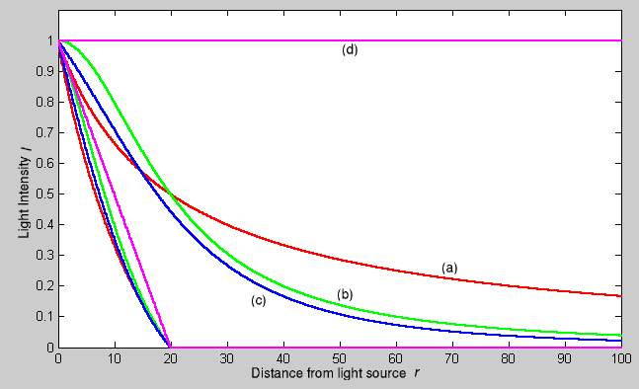

Custom Curve
The Custom Curve lamp Falloff type is very flexible.
Most other lamp falloff types work by having their light intensity start at its maximum (when nearest to the light source) and then with some predetermined pattern decrease their light intensity when the distance from the light source increases.
When using the Custom Curve Lamp Falloff type, a new panel is created called Falloff Curve. This Falloff Curve profile graph allows the user to alter how intense light is at a particular point along a light’s attenuation profile (i.e. at a specific distance from the light source).
The Falloff Curve profile graph has two axes, the Distance axis and the Intensity axis.
Distance axis
It represents the position at a particular point along a light source’s attenuation path. The far left is at the position of the light source and the far right is the place where the light source’s influence would normally be completely attenuated. I say “normally would” because the Falloff Curve can be altered to do the exact opposite if required.
Intensity axis
It represents the intensity at a particular point along a light source’s attenuation path. Higher intensity is represented by being higher up the intensity axis, while lower intensity light is represented by being lower down on the intensity axis.
Altering the Falloff Curve profile graph is easy. Just LMB click on a part of the graph you want to alter and drag it where you want it to be. If when you click you are over or near one of the tiny black square handles, it will turn white, indicating that this handle is now selected, and you will be able to drag it to a new position. If when you click on the graph you are not near a handle, one will be created at the point that you clicked, which you can then drag where you wish. You can also create handles at specific parts of the graph, clicking with LMB while holding Ctrl key; it will create a new handle at the point you have clicked.
In the example below (the default for the Falloff Curve Profile Graph), the graph shows that the intensity of the light starts off at its maximum (when near the light), and linearly attenuates as it moves to the right (further away from the light source).
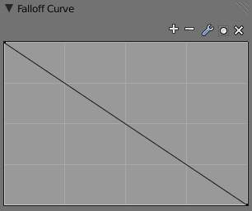  Default Falloff Curve panel graph. | 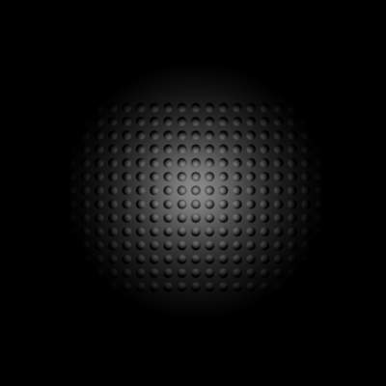  Render showing the Custom Curve lamp falloff type effect with default settings.
If you want to have a light attenuation profile that gets more intense as it moves away from the light source, you could alter the graph as below:
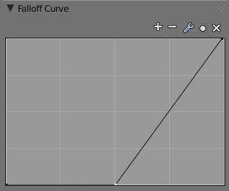  Falloff Curve for reversed attenuation. | 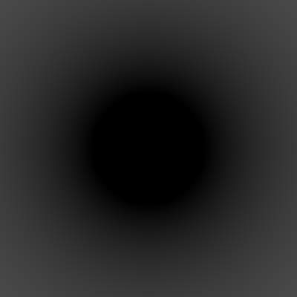  Falloff Curve for reversed attenuation rendered.
You are obviously not just limited to simple changes such as reversing the attenuation profile, you can have almost any profile you desire.
Here is another example of a different Falloff Curve profile graph, along with its resultant render output:
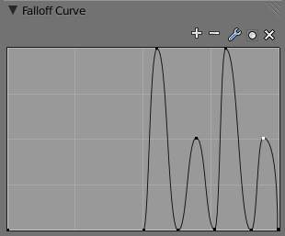  Oscillating attenuation profile. | 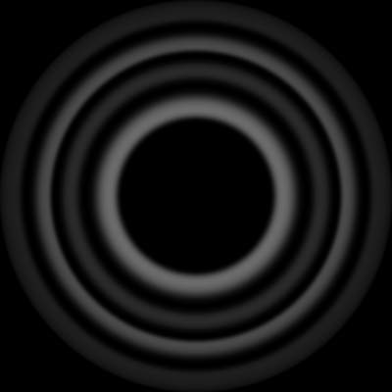  Render showing the effects of a “wavelet” profile graph on the light attenuation.

Inverse Square
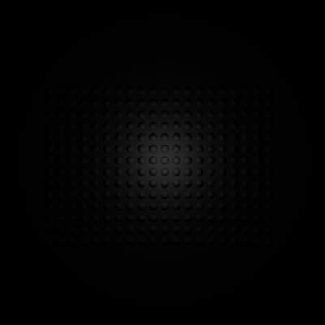
Render showing the Inverse Square lamp falloff type effect with default settings.
This lamp falloff type attenuates its intensity according to inverse square law, scaled by the Distance value. Inverse square is a sharper, realistic decay, useful for lighting such as desk lamps and street lights. This is similar to the old Quad option (and consequently, to the new Lin/Quad Weighted option with Linear to 0.0 and Quad to 1.0), with slight changes.

Inverse Linear
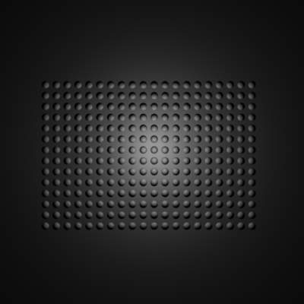
Render showing the Inverse Linear lamp falloff type effect with default settings.
This lamp falloff type attenuates its intensity linearly, scaled by the Dist value. This is the default setting, behaving the same as the default in previous Bforartists versions without Quad switched on, and consequently, like the new Lin/Quad Weighted option with Linear to 1.0 and Quad to 0.0. This isn’t physically accurate, but can be easier to light with.

Constant
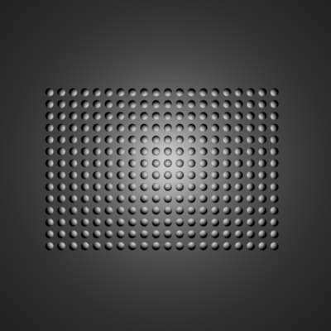
Render showing the Constant lamp falloff type effect with default settings.
This lamp falloff type does not attenuate its intensity with distance. This is useful for distant light sources like the sun or sky, which are so far away that their falloff isn’t noticeable. Sun and Hemi lamps always have constant falloff.

Sphere
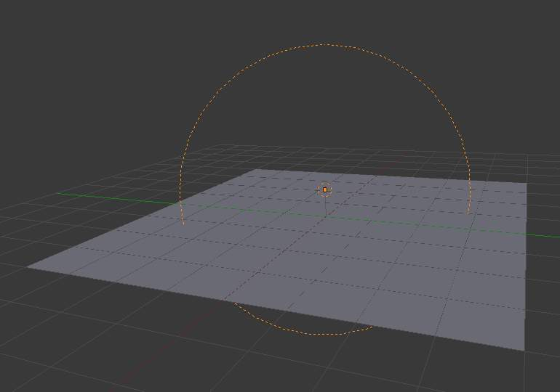
Screenshot of the 3D view window, showing the Sphere light clipping circle.
The Sphere option restricts the light illumination range of a Lamp or Spot lamp, so that it will completely stop illuminating an area once it reaches the number of Bforartists Units away from the Lamp, as specified in the Dist field.
When the Sphere option is active, a dotted sphere will appear around the light source, indicating the demarcation point at which this light intensity will be null.
The Sphere option adds a term to the chosen attenuation law, whatever it is:
I' = I × (D - r) / D if r < D; 0 otherwise
Where:
- I' is the required Intensity of light (with the Sphere option activated).
- I is the intensity of light calculated by the chosen attenuation law (without the Sphere option).
- D is the current setting of the Dist field.
- r is the distance from the lamp where the light intensity gets measured.
See the graphic at the end of the description of the Lin/Quad Weighted attenuation option.
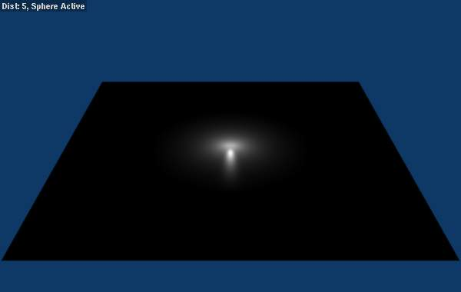  Render showing the light attenuation of a Constant falloff light type with the Sphere option active. | 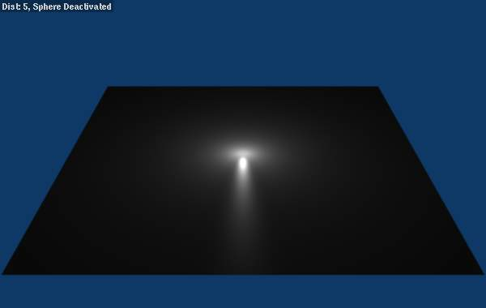  Render showing the light attenuation of a Constant falloff light type with the Sphere option deactivated.

Examples

Distance Example
In this example, the Lamp has been set pretty close to the group of planes. This causes the light to affect the front, middle and rear planes more dramatically. Looking at (Various Dist ance settings), you can see that as the Dist is increased, more and more objects become progressively brighter.

Various Distance settings (shadows disabled).
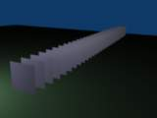  Distance: 10. | 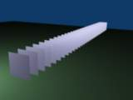  Distance: 100. | 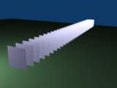  Distance: 1000.
The Distance parameter is controlling where the light is falling - at a linear rate by default - to half its original value from the light’s origin. As you increase or decrease this value, you are changing where this half falloff occurs. You could think of Distance as the surface of a sphere and the surface is where the light’s intensity has fallen to half its strength in all directions. Note that the light’s intensity continues to fall even after Distance. Distance just specifies the distance where half of the light’s energy has weakened.
Notice in (Distance : 1000) that the farthest objects are very bright. This is because the falloff has been extended far into the distance, which means the light is very strong when it hits the last few objects. It is not until 1000 units that the light’s intensity has fallen to half of its original intensity.
Contrast this with (Distance : 10), where the falloff occurs so soon that the farther objects are barely lit. The light’s intensity has fallen by a half by time it even reaches the tenth object.
You may be wondering why the first few planes appear to be dimmer? This is because the surface angle between the light and the object’s surface normal is getting close to oblique. That is the nature of a Lamp light object. By moving the light infinitely far away you would begin to approach the characteristics of the Sun lamp type.

Inverse Square Example
Inverse Square makes the light’s intensity falloff with a non-linear rate, or specifically, a quadratic rate. The characteristic feature of using Inverse Square is that the light’s intensity begins to fall off very slowly but then starts falling off very rapidly. We can see this in the (Inverse Square selected) images.

Inverse Square selected (with the specified distances).
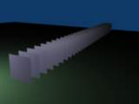  Inverse Square with 10. | 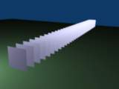  Inverse Square with 100. | 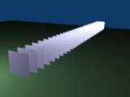  Inverse Square with 1000.
With Inverse Square selected, the Distance field specifies where the light begins to fall off faster, roughly speaking; see the light attenuation description in Falloff types for more info.
In (Inverse Square with 10), the light’s intensity has fallen so quickly that the last few objects aren’t even lit.
Both (Inverse Square with 100) and (Inverse Square with 1000) appear to be almost identical and that is because the Distance is set beyond the farthest object’s distance which is at about 40 BU out. Hence, all the objects get almost the full intensity of the light.
As above, the first few objects are dimmer than farther objects because they are very close to the light. Remember, the brightness of an object’s surface is also based on the angle between the surface normal of an object and the ray of light coming from the lamp.
This means there are at least two things that are controlling the surface’s brightness: intensity and the angle between the light source and the surface’s normal.

Sphere Example
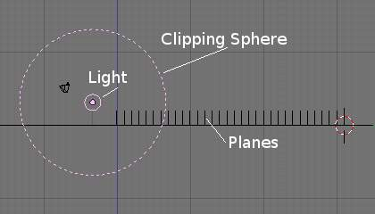
Clipping Sphere.
Sphere indicates that the light’s intensity is null at the Distance distance and beyond, regardless of the chosen light’s falloff. In (Clipping Sphere) you can see a side view example of the setup with Sphere enabled and a distance of 10.
Any objects beyond the sphere receive no light from the lamp.
The Distance field is now specifying both where the light’s rays become null, and the intensity’s ratio falloff setting. Note that there is no abrupt transition at the sphere: the light attenuation is progressive (for more details, see the descriptions of the Sphere and Falloff types above).

Sphere enabled with the specified distances, Inverse Linear light falloff.
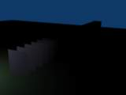  Sphere with 10. | 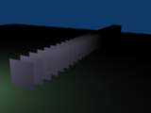  Sphere with 20. | 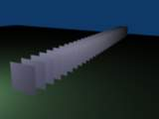  Sphere with 40.
In (Sphere with 10), the clipping sphere’s radius is 10 units, which means the light’s intensity is also being controlled by 10 units of distance. With a linear attenuation, the light’s intensity has fallen very low even before it gets to the first object.
In (Sphere with 20), the clipping sphere’s radius is now 20 BU and some light is reaching the middle objects.
In (Sphere with 40), the clipping sphere’s radius is now 40 units, which is beyond the last object. However, the light doesn’t make it to the last few objects because the intensity has fallen to nearly 0.
Hint
If a Lamp light is set to not cast shadows, it illuminates through walls and the like. If you want to achieve some nice effects like a fire, or a candle-lit room interior seen from outside a window, the Sphere option is a must. By carefully working on the Distance value you can make your warm firelight shed only within the room, while illuminating outside with a cool moonlight, the latter achieved with a Sun or Hemi light or both.

Lamps Textures

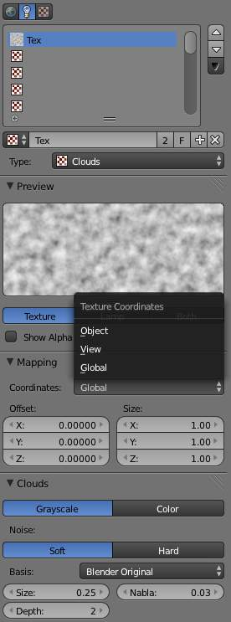
Lamp Texture panels
When a new lamp is added, it produces light in a uniform, flat color. While this might be sufficient in simple renderings, more sophisticated effects can be accomplished through the use of textures. Subtle textures can add visual nuance to a lamp, while hard textures can be used to simulate more pronounced effects, such as a disco ball, dappled sunlight breaking through treetops, or even a projector. These textures are assigned to one of ten channels, and behave exactly like material textures, except that they affect a lamp’s color and intensity, rather than a material’s surface characteristics.

Options
The lamp textures settings are grouped into two panels. Here we will only talk about the few things that differ from object material textures; see the Materials and Textures chapters for details about the standard options.
The texture-specific and the Mapping panels remain the same. However, you’ll note there are much fewer Mapping options - you can only choose between Global, View or another Object ‘s texture coordinates (since a lamp has no texture coordinates by itself), and you can scale or offset the texture.
The Mapping panel is also a subset of its regular material’s counterpart. You can only map a lamp texture to its regular, basic Color and/or to its Shadow color. As you can only affect colors, and a lamp has no texture coordinates on its own, the Diffuse, Specular, Shading, and Geometry options have disappeared.

What the Light Affects

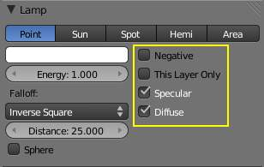
Lamp panel with the light affecting options highlighted
Every lamp has a set of switches that control which objects receive its light, and how it interacts with materials.
Negative
The light produced by the lamp is subtracted from the one “available” on the surfaces it hits, which darkens these surfaces instead of brightening them.
This Layer Only
Causes the lamp to only light objects on the same layer.
Diffuse
Prevents the lamp from producing diffuse light (it doesn’t really “light” things).
Specular
Prevents the lamp from producing specular highlights.

Lamps Related Settings

Here are some options closely related to light sources, without being lamps settings.

Lighting Groups

Materials
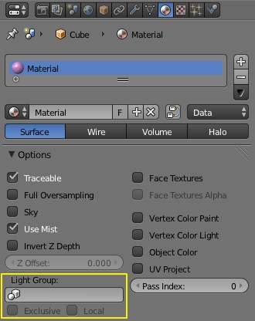
Light Group options for Materials
By default, materials are lit by all lamps in all visible layers, but a material (and thus all objects using that material) can be limited to a single group of lamps. This sort of control can be incredibly useful, especially in scenes with complex lighting setups. To enable this, navigate to the Material menu’s Options panel and select a group of lamps in the Light Group field. Note that a light group must be created first.
If the Exclusive button is enabled, lights in the specified group will only affect objects with this material.

Render Layers
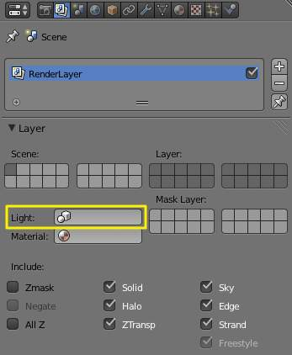
Light Group options for Render Layers
There’s a similar control located in the Layer panel of the context Render Layers. If a light group name is selected in this Light field, the scene will be lit exclusively by lamps in the specified group.

See Also
- Lamps Introduction
- Shadows
- Materials Introduction

Shadows

Light wouldn’t even exist without its counterpart: shadows. Shadows are a darkening of a portion of an object because light is being partially or totally blocked from illuminating the object. They add contrast and volume to a scene; there is nearly no place in the real world without shadows, so to get realistic renders, you will need them. Bforartists supports the following kinds of shadows:
- Lamps: Ray-traced Shadows
- Lamps: Buffered Shadows
- Ambient occlusion
- Indirect lighting
Ambient occlusion really isn’t a shadow based on light per se, but based on geometry. However, it does mimic an effect where light is prevented from fully and uniformly illuminating an object, so it is mentioned here. Also, it is important to mention ambient lighting, since increasing Ambient decreases the effect of a shadow.
You can use a combination of ray-traced and buffer shadows to achieve different results. Even within ray-traced shadows, different lamps cast different patterns and intensities of shadow. Depending on how you arrange your lamps, one lamp may wipe out or override the shadow cast by another lamp.
Shadows is one of those trifectas in Bforartists, where multiple things have to be set up in different areas to get results:
- The lamp has to cast shadows (ability and direction).
- An opaque object has to block light on its way (position and layer).
- Another object’s material has to receive shadows (Shadow and Receive Transparent enabled).
- The render engine has to calculate shadows (Shadow for buffered shadows, Shadow and Ray for ray-traced shadows).
For example, the simple Lamp, Area, and Sun light has the ability to cast ray shadows, but not buffer shadows. The Spot light can cast both, whereas the Hemi light does not cast any. If a Sun lamp is pointing sideways, it will not cast a shadow from a sphere above a plane onto the plane, since the light is not traveling that way. All lamps able to cast shadows share some common options, described here.
Just to give you more shadow options (and further confuse the issue), lamps and materials can be set to respectively only cast and receive shadows, and not light the diffuse/specular aspects of the object. Also, render layers can turn on/off the shadow pass, and their output may or may not contain shadow information...

Lamps: Ray-traced Shadows
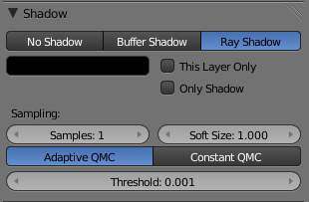
Ray Shadow enabled for a lamp
Ray-traced shadows produce very precise shadows with very low memory use, but at the cost of processing time. This type of shadowing is available to all lamp types except Hemi.
As opposed to buffered shadows (Lamps: Buffered Shadows), ray-traced shadows are obtained by casting rays from a regular light source, uniformly and in all directions. The ray-tracer then records which pixel of the final image is hit by a ray light, and which is not. Those that are not are obviously obscured by a shadow.
Each light casts rays in a different way. For example, a Spot light casts rays uniformly in all directions within a cone. The Sun light casts rays from a infinitely distant point, with all rays parallel to the direction of the Sun light.
For each additional light added to the scene, with ray-tracing enabled, the rendering time increases. Ray-traced shadows require more computation than buffered shadows but produce sharp shadow borders with very little memory resource usage.
To enable ray-traced shadows, three actions are required:
- Enable Shadows globally in the Render menu’s Shading panel.
- Enable Ray tracing globally from the same panel.
- Enable ray-traced shadows for the light using the Ray Shadow button in the Light menu’s Shadow panel. This panel varies depending on the type of light.
  - All lamps able to cast ray-traced shadows share some common options, described in Ray-traced Properties.
Ray-traced shadows can be cast by the following types of lamp:
- Point lamp
- Spot lamp
- Area lamp
- Sun lamp

Lamps: Buffered Shadows
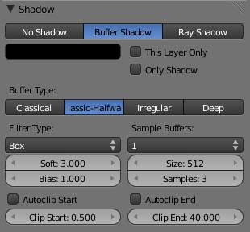
Buffer Shadow enabled for a Spot lamp
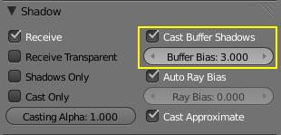
Cast Buffer Shadows enabled for a material
Buffered shadows provide fast-rendered shadows at the expense of precision and/or quality. Buffered shadows also require more memory resources as compared to ray tracing. Using buffered shadows depends on your requirements. If you are rendering animations or can’t wait hours to render a complex scene with soft shadows, buffer shadows are a good choice.
For a scanline renderer - and Bforartists’s built-in engine is, among other things, a scanline renderer - shadows can be computed using a shadow buffer. This implies that an “image”, as seen from the spot lamp’s point of view, is “rendered” and that the distance - in the image - for each point from the spot light is saved. Any point in the “rendered” image that is farther away than any of those points in the spot light’s image is then considered to be in shadow. The shadow buffer stores this image data.
To enable buffered shadows these actions are required:
- Enable shadows globally from the Scene menu’s Gather panel by selecting Approximate.
- Enable shadows for the light using the Buffer Shadow button in the Lamp menu’s Shadow panel.
- Make sure the Cast Buffer Shadows options is enabled in each Material ‘s Shadow panel.
- The Spot lamp is the only lamp able to cast buffered shadows.

Common Shadowing Lamps Options

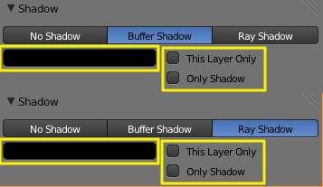
Common shadowing options for lamps
All lamps able to cast shadows (Lamp, Spot, Area and Sun) share some options, described below:
This Layer Only
When this option is enabled, only the objects on the same layer as the light source will cast shadows.
Only Shadow
The light source will not illuminate an object but will generate the shadows that would normally appear. This feature is often used to control how and where shadows fall by having a light which illuminates but has no shadow, combined with a second light which doesn’t illuminate but has Only Shadow enabled, allowing the user to control shadow placement by moving the “Shadow Only” light around.
Shadow color
This color picker control allows you to choose the color of your cast shadows (black by default). The images below were all rendered with a white light and the shadow color was selected independently.
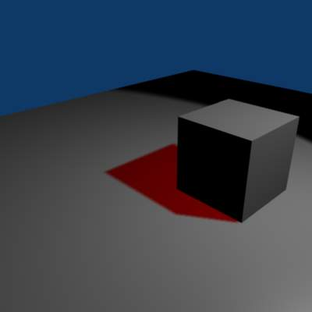  Red colored shadow example | 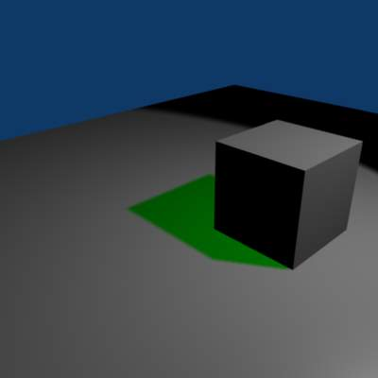  Green colored shadow example | 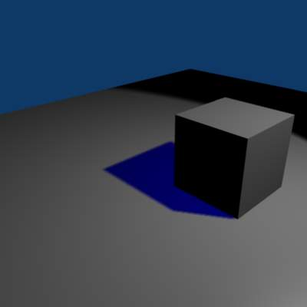  Blue colored shadow example

Although you can select a pure white color for a shadow color, it appears to make a shadow disappear.

See Also
- Shadows
- Common Raytraced Options
- Lamp Light Raytraced Shadows
- Spot Light Raytraced Shadows
- Area Light Raytraced Shadows
- Sun Light Raytraced Shadows
- Spot Light Buffered Shadows

Lamps Raytraced Shadows

Ray shadowing options for lamps
Most lamp types (Lamp, Spot and Sun) share the same options for the ray-traced shadows generation, which are described below. Note that the Area lamp, even though using most of these options, have some specifics described in its own ray-traced shadows page.
Ray Shadow
The Ray Shadow button enables the light source to generate ray-traced shadows. When the Ray Shadow button is selected, another set of options is made available, those options being:
Shadow sample generator type
Method for generating shadow samples: Adaptive QMC is fastest, Constant QMC is less noisy but slower. This allows you to choose which algorithm is to be used to generate the samples that will serve to compute the ray-traced shadows (for now, mainly two variants of Quasi-Monte Carlo, see What is Quasi-Monte Carlo?):
Constant QMC
The Constant QMC method is used to calculate shadow values in a very uniform, evenly distributed way. This method results in very good calculation of shadow value but it is not as fast as using the Adaptive QMC method; however, Constant QMC is more accurate.
Adaptive QMC
The Adaptive QMC method is used to calculate shadow values in a slightly less uniform and distributed way. This method results in good calculation of shadow value but not as good as Constant QMC. The advantage of using Adaptive QMC is that it is in general much quicker while being not much worse than Constant QMC in terms of overall results.
Samples
Number of extra samples taken (samples x samples). This slider sets the maximum number of samples that both Constant QMC and Adaptive QMC will use to do their shadow calculations. The maximum value is 16 - the real number of samples is actually the square of it, so setting a sample value of 3 really means 32 = 9 samples will be taken.
Soft Size
Light size for ray shadow sampling. This slider determines the size of the fuzzy/diffuse/penumbra area around the edge of a shadow. Soft Size only determines the width of the soft shadow size, not how graded and smooth the shadow is. If you want a wide shadow which is also soft and finely graded, you must also set the number of samples in the Samples field higher than 1; otherwise this field has no visible effect and the shadows generated will not have a soft edge. The maximum value for Soft Size is 100.0.
Below is a table of renders with different Soft Size and Samples settings showing the effect of various values on the softness of shadow edges:
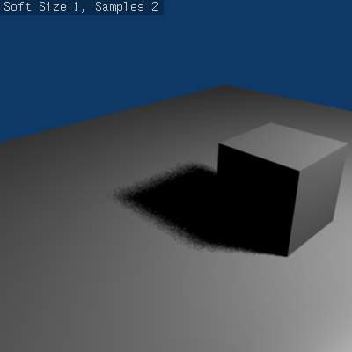  Soft Size: 1.0, Samples: 2. | 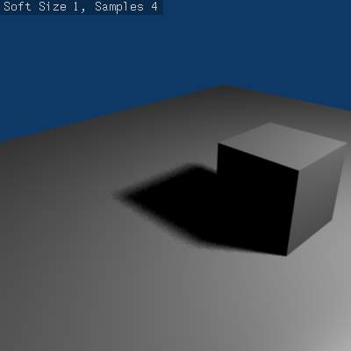  Soft Size: 1.0, Samples: 4. | 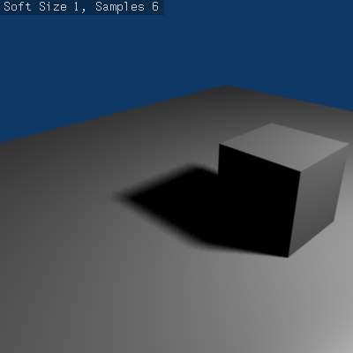  Soft Size: 1.0, Samples: 6.
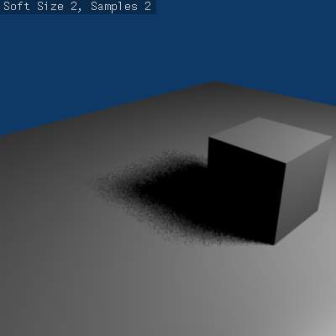  Soft Size: 2.0, Samples: 2. | 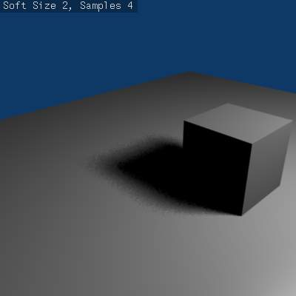  Soft Size: 2.0, Samples: 4. | 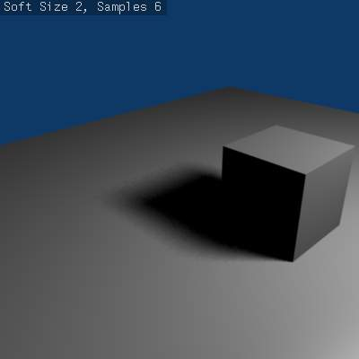  Soft Size: 2.0, Samples: 6.
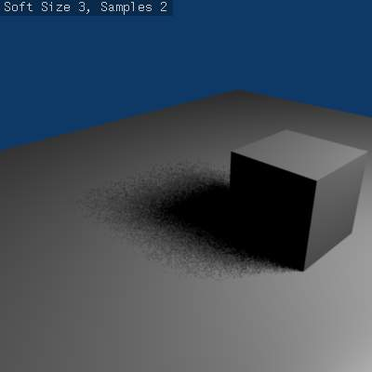  Soft Size: 3.0, Samples: 2. | 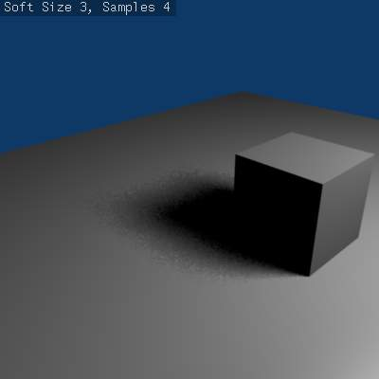  Soft Size: 3.0, Samples: 4. | 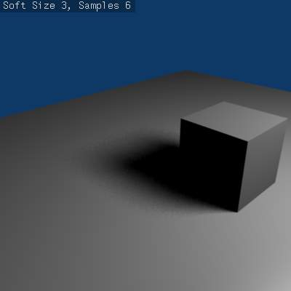  Soft Size: 3.0, Samples: 6.
Below is an animated version of the above table of images showing the effects:
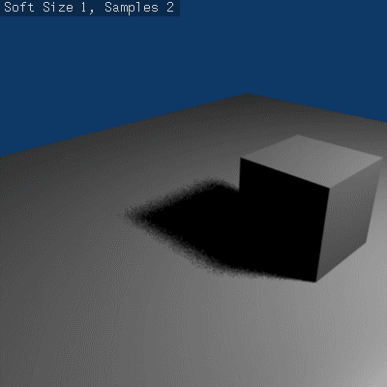
Animated version renders with different Soft Size and Samples settings showing the effect of various values on the softness of shadow edges.
Threshold
Threshold for Adaptive Sampling. This field is used with the Adaptive QMC shadow calculation method. The value is used to determine if the Adaptive QMC shadow sample calculation can be skipped based on a threshold of how shadowed an area is already. The maximum Threshold value is 1.0.

What is Quasi-Monte Carlo?
The Monte Carlo method is a method of taking a series of samples/readings of values (any kind of values, such as light values, color values, reflective states) in or around an area at random, so as to determine the correct actions to take in certain calculations which usually require multiple sample values to determine overall accuracy of those calculations. The Monte Carlo method tries to be as random as possible; this can often cause areas that are being sampled to have large irregular gaps in them (places that are not sampled/read). This in turn can cause problems for certain calculations (such as shadow calculation).
The solution to this was the Quasi-Monte Carlo method.
The Quasi-Monte Carlo method is also random, but tries to make sure that the samples/readings it takes are also better distributed (leaving less irregular gaps in its sample areas) and more evenly spread across an area. This has the advantage of sometimes leading to more accurate calculations based on samples/reading.

Volumetric Lighting

According to Wikipedia, volumetric lighting
is a technique used in 3D computer graphics to add lighting effects to a rendered scene. It allows the viewer to see beams of light shining through the environment; seeing sunbeams streaming through an open window is an example of volumetric lighting, also known as God rays. The term seems to have been introduced from cinematography and is now widely applied to 3D modeling and rendering especially in the field of 3D gaming. In volumetric lighting, the light cone emitted by a light source is modeled as a transparent object and considered as a container of a “volume”: as a result, light has the capability to give the effect of passing through an actual three dimensional medium (such as fog, dust, smoke, or steam) that is inside its volume, just like in the real world.
A classic example is the search light with a visible halo/shaft of light being emitted from it as the search light sweeps around.
By default Bforartists does not model this aspect of light. For example when Bforartists lights something with a Spot light, you see the objects and area on the floor lit but not the shaft/halo of light coming from the spotlight as it progresses to its target and would get scattered on the way.
The halo/shaft of light is caused in the real world by light being scattered by particles in the air, some of which get diverted into your eye and that you perceive as a halo/shaft of light. The scattering of light from a source can be simulated in Bforartists using various options, but by default is not activated.
The only lamp able to create volumetric effects is the Spot lamp (even thought you might consider some of the “Sky & Atmosphere” effects of the Sun lamp as volumetric as well).

See also
- Mist
- Smoke
- Volumetric Materials

Lamps

Bforartists comes equipped with five different lamp types, each with its own unique strengths and limitations. Here are the available lamps:
- Point is an omni-directional point light source, similar to a light bulb.
- Spot is a directional point light source, similar to ... a spot.
- Area is a source simulating an area which is producing light, as windows, neons, TV screens.
- Hemi simulates a very wide and far away light source, like the sky.
- Sun simulates a very far away and punctual light source, like the sun.
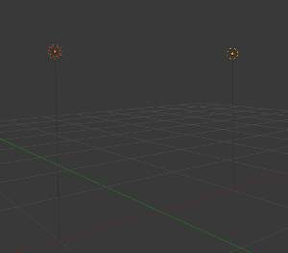
Visual height and shadow markers of two points lamps. Ray Shadow is enabled on the left lamp.
You can add new lamps to a scene using the Add menu in the top header, or with ([Shift][A] ‣ Add ‣ Lamp).
Once added, a lamp’s position is indicated in the 3D View by a solid dot in a circle, but most types also feature dashed wire-frames that help describe their orientation and properties. While each type is represented differently, there are some visual indicators common to all of them:
Shadows
If shadows are enabled, an additional dashed circle is drawn around the solid circle. This makes it easier to quickly determine if a lamp has shadows enabled.
Vertical Height Marker
This is a dim gray line, which helps locate the lamp’s position relative to the global X-Y plane.

Point

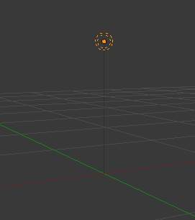
Point lamp
The Point lamp is an omni-directional point of light, that is, a point radiating the same amount of light in all directions. It’s visualized by a plain, circled dot. Being a point light source, the direction of the light hitting an object’s surface is determined by the line joining the lamp and the point on the surface of the object itself.
Light intensity/energy decays based on (among other variables) distance from the Point lamp to the object. In other words, surfaces that are further away are rendered darker.

Lamp Options
Distance, Energy and Color
These settings are common to most types of lamps, and are described in Light Properties.
Negative, This Layer Only, Specular, and Diffuse
These settings control what the lamp affects, as described in What Light Affects.
Falloff and Sphere
These settings control how the light of the Lamp decays with distance. See Light Attenuation for details.

Shadows
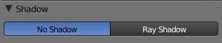
Without ray shadows
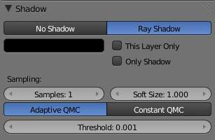
Point lamp with ray shadows and Adaptive QMC sample generator enabled
The Point light source can only cast ray-traced shadows. It shares with other lamp types the common shadow options described in Shadow Properties.
The ray-traced shadows settings of this lamp are shared with other lamps, and are described Raytraced Properties.

Raytraced Shadows

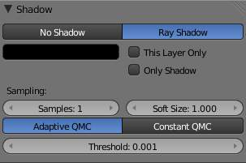
Shadow panel
The Point light source can only cast raytraced shadows. It shares with other lamp types the same common shadowing options, described in Shadows Properties.
The raytraced shadows settings of this lamp are shared with other ones, and are described in Raytraced Properties.

Spot

A Spot lamp emits a cone-shaped beam of light from the tip of the cone, in a given direction.
The Spot light is the most complex of the light objects and indeed, for a long time, among the most used thanks to the fact that it was the only one able to cast shadows. Nowadays, with a ray tracer integrated into Bforartists’s internal render engine, all lamps can cast shadows (except Hemi). Even so, Spot lamps’ shadow buffers are much faster to render than ray-traced shadows, especially when blurred/softened, and spot lamps also provide other functionality such as “volumetric” halos.

Lamp options
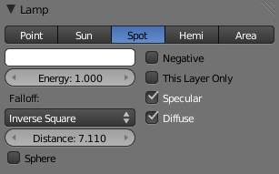
Common Lamp options of a Spot
Distance, Energy and Color
These settings are common to most types of lamps, and are described in Light Properties.
This Layer Only, Negative, Diffuse and Specular
These settings control what the lamp affects, as described in What Light Affects.
Light Falloff and Sphere
These settings control how the light of the Spot decays with distance. See Light Attenuation for details.
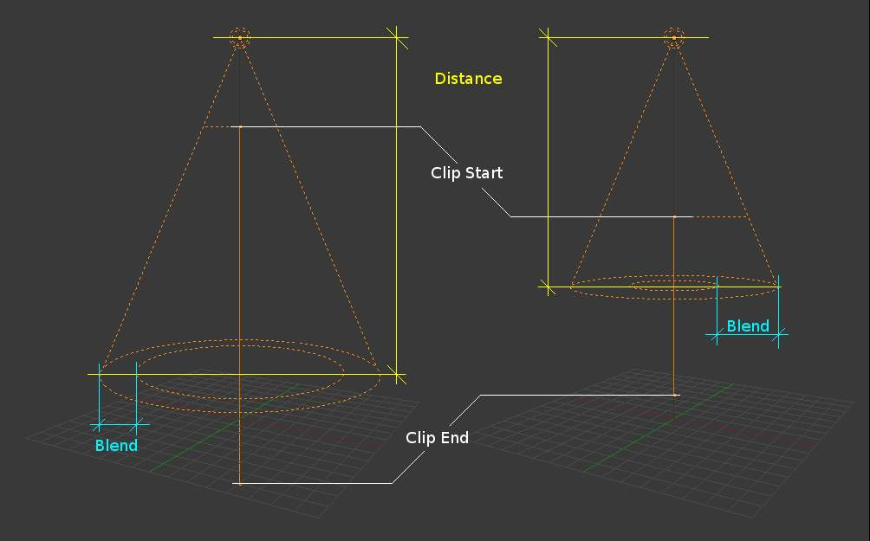
Changing the Spot options also changes the appearance of the spotlight as displayed in the 3D View

Shadows
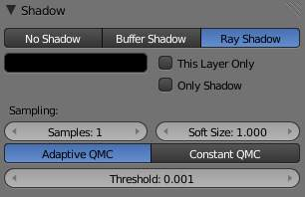
Shadow panel set to Ray Shadow
Spotlights can use either ray-traced shadows or buffered shadows. Either of the two can provide various extra options. Ray-traced shadows are generally more accurate, with extra capabilities such as transparent shadows, although they are quite slower to render.
No Shadow
Choose this to turn shadows off for this spot lamp. This can be useful to add some discreet directed light to a scene.
Buffer Shadow
Buffered Shadows are also known as depth map shadows. Shadows are created by calculating differences in the distance from the light to scene objects. See Buffered Shadows for full details on using this feature. Buffered shadows are more complex to set up and involve more faking, but the speed of rendering is a definite advantage. Nevertheless, it shares with other lamp types common shadow options described in Shadows Properties.
Ray Shadow
The ray-traced shadows settings of this lamp are shared with other lamps, and are described in Raytraced Properties.

Spot Shape
Size
The size of the outer cone of a Spot, which largely controls the circular area a Spot light covers. This slider in fact controls the angle at the top of the lighting cone, and can be between 1.0- `` and ``180.0.

Changing the spot Size option
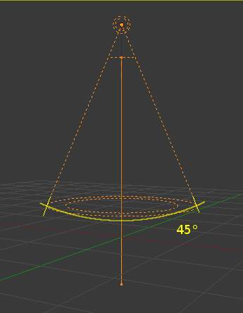 | 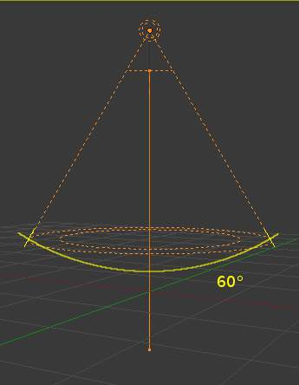
Blend
The Blend slider controls the inner cone of the Spot. The Blend value can be between 0.0 and 1.0. The value is proportional and represents that amount of space that the inner cone should occupy inside the outer cone (Size).
The inner cone boundary line indicates the point at which light from the Spot will start to blur/soften; before this point its light will mostly be full strength. The larger the value of Blend the more blurred/soft the edges of the spotlight will be, and the smaller the inner cone’s circular area will be (as it starts to blur/soften earlier).
To make the Spot have a sharper falloff rate and therefore less blurred/soft edges, decrease the value of Blend. Setting Blend to 0.0 results in very sharp spotlight edges, without any transition between light and shadow.
The falloff rate of the Spot lamp light is a ratio between the Blend and Size values; the larger the circular gap between the two, the more gradual the light fades between Blend and Size.
Blend and Size only control the Spot light cone’s aperture and softness (“radial” falloff); they do not control the shadow’s softness as shown below.
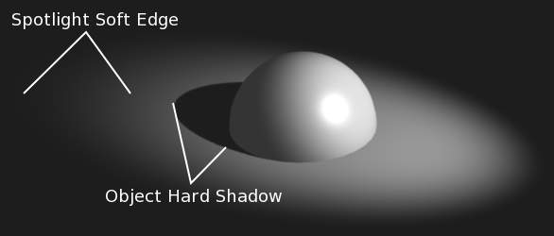
Render showing the soft edge spotlighted area and the sharp/hard object shadow
Notice in the picture above that the object’s shadow is sharp as a result of the ray tracing, whereas the spotlight edges are soft. If you want other items to cast soft shadows within the Spot area, you will need to alter other shadow settings.
Square
The Square button makes a Spot light cast a square light area, rather than the default circular one.
Show Cone
Draw a transparent cone in 3D view to visualize which objects are contained in it.
Halo
Adds a volumetric effects to the spot lamp. See Spot Halos.

Raytraced Shadows

Shadow panel
The Spot light source can only cast raytraced shadows. It shares with other lamp types the same common shadowing options, described in Shadows Properties.
The raytraced shadows settings of this lamp are shared with other ones, and are described in Raytraced Properties.

Spot Buffered Shadows

Buffer Shadow enabled for a Spot lamp
Spotlights can use either Raytraced Shadows or buffered shadows. Either of the two can provide various extra options.
Raytraced shadows are generally more accurate, with extra capabilities such as transparent shadows, although they are quite slower to render.
Buffered shadows are more complex to set up and involve more faking, but the speed of rendering is a definite advantage. Nevertheless, it shares with other lamp types common shadows options described in Shadows Properties.

Shadow Buffer Types
When the Buffer Shadow button is activated, the currently selected Spot light generates shadows, using a “shadow buffer” rather than using raytracing, and various extra options and buttons appear in the Shadow panel.
Buffer Type
There more than one way to generate buffered shadows. The shadow buffer generation type controls which generator to use.
There are four shadow generation types, those being:
- Classical
- Classic-Halfway
- Irregular
- Deep
For more information on the different shadow generation methods see these links:
- Development Release Logs 2.43: Irregular Shadow Buffer
- Bforartists Nation: Bforartists Gets Irregular Shadow Buffers
- Development Release Logs 2.43: Shadow Buffer Halfway Average

“Classical” and “Classic-Halfway”
Buffer Shadowset to Classic-Halfway
Classical
A shadow generation which used to be the Bforartists default and unique method for generation of buffered shadows. It used an older way of generating buffered shadows, but it could have some problems with accuracy of the generated shadows and can be very sensitive to the resolution of the shadow buffer (Shadow Buffer –> Size), different Bias values, and all the self-shadowing issues that brings up.
The Classical method of generating shadows is obsolete and is really only still present to allow for backward compatibility with older versions of Bforartists. In most other cases you will want to use Classic-Halfway instead.
Classic-Halfway
This shadow buffer type is an improved shadow buffering method and is the default option selected in Bforartists. It works by taking an averaged reading of the first and second nearest Z depth values allowing the Bias value to be lowered and yet not suffer as much from self-shadowing issues.
Not having to increase Bias values helps with shadow accuracy, because large Bias values can mean small faces can lose their shadows, as well as preventing shadows being overly offset from the larger Bias value.
Classic-Halfway doesn’t work very well when faces overlap, and biasing problems can happen.
Here are now the options specific to these generation methods:
Size
The Size numeric field can have a value from 512 to 10240. Size represents the resolution used to create a shadow map. This shadow map is then used to determine where shadows lay within a scene.
As an example, if you have a Size with a value of 1024, you are indicating that the shadow data will be written to a buffer which will have a square resolution of 1024×1024 pixels/samples from the selected spotlight.
The higher the value of Size, the higher resolution and accuracy of the resultant shadows, assuming all other properties of the light and scene are the same, although more memory and processing time would be used. The reverse is also true - if the Size value is lowered, the resultant shadows can be of lower quality, but would use less memory and take less processing time to calculate.
As well as the Size value affecting the quality of generated shadows, another property of Spot lamps that affects the quality of their buffered shadows is the angle of the spotlights lighted area (given in the Spot Shape panel’s Size field).
As the spot shape Size value is increased, the quality of the cast shadows degrades. This happens because when the Spot lighted area is made larger (by increasing spot shape Size), the shadow buffer area has to be stretched and scaled to fit the size of the new lighted area.
The Size resolution is not altered to compensate for the change in size of the spotlight, so the quality of the shadows degrades. If you want to keep the generated shadows the same quality, as you increase the spot shape Size value, you also need to increase the buffer Size value.

Note
The above basically boils down to
If you have a spotlight that is large you will need to have a larger buffer Size to keep the shadows good quality. The reverse is true also - the quality of the generated shadows will usually improve (up to a point) as the Spot lamp covers a smaller area.

Filter Type
The Box, Tent, and Gauss filter types control what filtering algorithm to use to anti-alias the buffered shadows.
They are closely related to the Samples numeric field, as when this setting is set to 1, shadow filtering is disabled, so none of these buttons will have any effect what soever.
Box
The buffered shadows will be anti-aliased using the “box” filtering method. This is the original filter used in Bforartists. It is relatively low quality and is used for low resolution renders, as it produces very sharp anti-aliasing. When this filter is used, it only takes into account oversampling data which falls within a single pixel, and doesn’t take into account surrounding pixel samples. It is often useful for images which have sharply angled elements and horizontal/vertical lines.
Tent
The buffered shadows will be anti-aliased using the “tent” filtering method. It is a simple filter that gives sharp results, an excellent general purpose filtering method. This filter also takes into account the sample values of neighboring pixels when calculating its final filtering value.
Gauss
The buffered shadows will be anti-aliased using the “Gaussian” filtering method. It produces a very soft/blurry anti-aliasing. As result, this filter is excellent with high resolution renders.
The Anti-Aliasing page in the Render chapter will give more information on the various filtering/distribution methods and their uses.
Samples
The Samples numeric field can have a value between 1 and 16. It controls the number of samples taken per pixel when calculating shadow maps.
The higher this value, the more filtered, smoothed and anti-aliased the shadows cast by the current lamp will be, but the longer they will take to calculate and the more memory they will use. The anti-aliasing method used is determined by having one of the Box, Tent or Gauss buttons activated (see above).
Having a Samples value of 1 is similar to turning off anti-aliasing for buffered shadows.
Soft
The Soft numeric field can have a value between 1.0 and 100.0. It indicates how wide an area is sampled when doing anti-aliasing on buffered shadows. The larger the Soft value, the more graduated/soft the area that is anti-aliased/softened on the edge of generated shadows.
Sample Buffers
The Sample Buffers setting can be set to values 1, 4 or 9, and represents the number of shadow buffers that will be used when doing anti-aliasing on buffered shadows.
This option is used in special cases, like very small objects which move and need to generate really small shadows (such as strands). It appears that normally, pixel width shadows don’t anti-alias properly, and that increasing Buffer Size doesn’t help much.
So this option allows you to have a sort of extra sample pass, done above the regular one (the one controlled by the Box / Tent / Gauss, Samples and Soft settings).
The default 1 value will disable this option.
Higher values will produce a smoother anti-aliasing - but be careful: using a Sample Buffers of 4 will require four times as much memory and process time, and so on, as Bforartists will have to compute that number of sample buffers.

“Irregular”
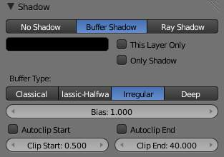
Buffer Shadow set to Irregular
Irregular shadow method is used to generate sharp/hard shadows that are placed as accurately as raytraced shadows. This method offers very good performance because it can be done as a multi-threaded process.
This method supports transparent shadows. To do so, you will first need to setup the shadow setting for the object which will receive the transparent shadow. (Material –> Shadow –> Cat Buffer Shadows and Buffer Bias)

Deep generation method
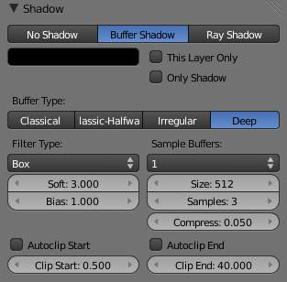
Buffer Shadow set to Deep
Deep Shadow buffer supports transparency and better filtering, at the cost of more memory usage and processing time
Compress
Deep shadow map compression threshold.

Common options
The following settings are common to all buffered shadow generation method.
Bias
The Bias numeric field can have a value between 0.001 and 5.0. Bias is used to add a slight offset distance between an object and the shadows cast by it. This is sometimes required because of inaccuracies in the calculation which determines weather an area of an object is in shadow or not.
Making the Bias value smaller results in the distance between the object and its shadow being smaller. If the Bias value is too small, an object can get artifacts, which can appear as lines and interference patterns on objects. This problem is usually called “self shadowing”, and can usually be fixed by increasing the Bias value, which exists for that purpose!
Other methods for correcting self shadowing include increasing the size of the Shadow Buffer Size or using a different buffer shadow calculation method such as Classic-Halfway or Irregular.
Self shadowing interference tends to affect curved surfaces more than flat ones, meaning that if your scene has a lot of curved surfaces it may be necessary to increase the Bias value or Shadow Buffer Size value.
Having overly large Bias values not only places shadows further away from their casting objects, but can also cause objects that are very small to not cast any shadow at all. At that point altering Bias, Shadow Buffer Size or Spot Size values, among other things, may be required to fix the problem.
Note
Finer Bias tuning
You can now refine the Bias value independently for each Material, using the Bias slider (Material menu, Shadow panel). This value is a factor by which the Bias value of each Spot buffered shadows lamp is multiplied, each time its light hits an object using this material. The 0.0 and 1.0 values are equivalent - they do not alter the lamp’s Bias original value.

Clip Start & Clip End
When a Spot light with buffered shadows is added to a scene, an extra line appears on the Spot 3D view representation.
The start point of the line represents Clip Start ‘s value and the end of the line represents Clip End ‘s value. Clip Start can have a value between 0.1 and 1000.0, and Clip End, between 1.0 and 5000.0. Both values are represented in Bforartists Units.
Clip Start indicates the point after which buffered shadows can be present within the Spot light area. Any shadow which could be present before this point is ignored and no shadow will be generated.
Clip End indicates the point after which buffered shadows will not be generated within the Spot light area. Any shadow which could be present after this point is ignored and no shadow will be generated.
The area between Clip Start and Clip End will be capable of having buffered shadows generated.
Altering the Clip Start and Clip End values helps in controlling where shadows can be generated. Altering the range between Clip Start and Clip End can help speed up rendering, save memory and make the resultant shadows more accurate.
When using a Spot lamp with buffered shadows, to maintain or increase quality of generated shadows, it is helpful to adjust the Clip Start and Clip End such that their values closely bound around the areas which they want to have shadows generated at. Minimizing the range between Clip Start and Clip End, minimizes the area shadows are computed in and therefore helps increase shadow quality in the more restricted area.
Autoclip Start & Autoclip End
As well as manually setting Clip Start and Clip End fields to control when buffered shadows start and end, it is also possible to have Bforartists pick the best value independently for each Clip Start and Clip End field.
Bforartists does this by looking at where the visible vertices are when viewed from the Spot lamp position.

Hints
Any object in Bforartists can act as a camera in the 3D view. Hence you can select the Spot light and switch to a view from its perspective by pressing Ctrl-Numpad0.

Spot Volumetric Effects

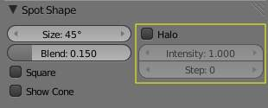
Spot lamps’s Halo options
Spot lights also can produce “volumetric” effects. See Volumetric Light for more information about what it means.
Halo
The Halo button allows a Spot lamp to have a volumetric effect applied to it. This button must be active if the volumetric effect is to be visible. Note that if you are using buffered shadows, you have extra options described in the Spot Buffered Shadows page.
Intensity
The Intensity slider controls how intense/dense the volumetric effect is that is generated from the light source. The lower the value of the Intensity slider, the less visible the volumetric effect is, while higher Intensity values give a much more noticeable and dense volumetric effect.
Step
This field can have a value between 0 and 12. It is used to determine whether this Spot will cast volumetric shadows, and what quality those volumetric shadows will have. If Step is set to a value of 0, then no volumetric shadow will be generated. Unlike most other controls, as the Step value increases, the quality of volumetric shadows decreases (but take less time to render), and vice versa.

Tip
Step values
A value of 8 for Halo Step is usually a good compromise between speed and accuracy.
Bforartists only simulates volumetric lighting in Spot lamps when using its internal renderer. This can lead to some strange results for certain combinations of settings for the light’s Energy and the halo’s Intensity. For example, having a Spot light with null or very low light Energy settings but a very high halo Intensity setting can result in a dark/black halo, which would not happen in the real world. Just be aware of this possibility when using halos with the internal renderer.

Note
The halo effect can be greatly enhanced when using buffered shadows: when the halo’s Step is not null, they can create “volumetric shadows”. See the page about Spot Buffered Shadows for more information.

See Also
- Shadows
- Spot Lamp
- Spot Buffered Shadows

Area

The Area lamp simulates light originating from a surface (or surface-like) emitter. For example, a TV screen, your supermarket’s neon lamps, a window, or a cloudy sky are just a few types of area lamp. The area lamp produces shadows with soft borders by sampling a lamp along a grid the size of which is defined by the user. This is in direct contrast to point-like artificial lights which produce sharp borders.
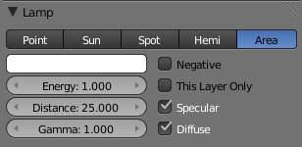
Commons Options

Lamp options
Distance, Energy and Color
These settings are common to most types of lamps, and are described in Light Properties.
Note that the Distance setting is much more sensitive and important for Area lamps than for others; usually any objects within the range of Distance will be blown out and overexposed. For best results, set the Distance to just below the distance to the object that you want to illuminate.
Gamma
Amount to gamma correct the brightness of illumination. Higher values give more contrast and shorter falloff.
The Area lamp doesn’t have light falloff settings. It uses an “inverse quadratic” attenuation law. The only way to control its falloff is to use the Distance and/or Gamma settings.
This Layer Only, Negative, Specular and Diffuse
These settings control what the lamp affects, as described in What Light Affects.

Shadows
Area light ray-traced shadows are described here: Raytraced Shadows.
When an Area light source is selected, the Shadow panel has the following default layout:

The Shadow panel when Area light source is selected.
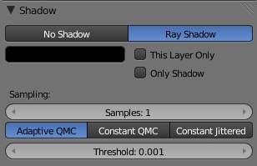 | 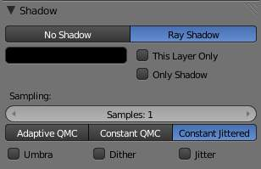
Adaptive QMC settings | Constant Jittered settings

Area Shape
The shape of the area light can be set to Square or Rectangle.
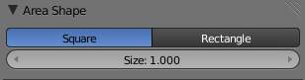
Square options
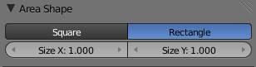
Rectangle options
Square / Rectangular
Emit light from either a square or a rectangular area
Size / Size X / Size Y
Dimensions for the Square or Rectangle
Note
Shape Tips
Choosing the appropriate shape for your Area light will enhance the believability of your scene. For example, you may have an indoor scene and would like to simulate light entering through a window. You could place a Rectangular area lamp in a window (vertical) or from neons (horizontal) with proper ratios for Size X and Size Y. For the simulation of the light emitted by a TV screen a vertical Square area lamp would be better in most cases.

Area Raytraced Shadows

Adaptive QMC settings
The Area light source can only cast ray-traced shadows. The ray-traced shadows settings of this lamp are mostly shared with other lamps, as described in Raytraced Properties. However, there are some specifics with this lamp, which are detailed below:

Shadow Samples
Samples
This have the same role as with other lamps, but when using a Rectangle Area lamp, you have two samples settings: Samples X and Samples Y, for the two axes of the area plane. Note also that when using the Constant Jittered sample generator method, this is more or less equivalent to the number of virtual lamps in the area. With QMC sample generator methods, it behaves similarly to with Lamp or Spot lamps.

Sample Generator Types
Adaptive QMC / Constant QMC
These common setting are described in Shadow Properties.
Constant Jittered settings
Constant Jittered
The Area lamp has a third sample generator method, Constant Jittered, which is more like simulating an array of lights. It has the same options as the old one: Umbra, Dither and Jitter.
The following three parameters are only available when using the Constant Jittered sample generator method, and are intended to artificially boost the “soft” shadow effect, with possible loss in quality:
Umbra
Emphasizes the intensity of shadows in the area fully within the shadow rays. The light transition between fully shadowed areas and fully lit areas changes more quickly (i.e. a sharp shadow gradient). You need Samples values equal to or greater than 2 to see any influence of this button.
Dither
Applies a sampling over the borders of the shadows, similar to the way anti-aliasing is applied by the OSA button on the borders of an object. It artificially softens the borders of shadows; when Samples is set very low, you can expect poor results, so Dither is better used with medium Samples values. It is not useful at all with high Samples values, as the borders will already appear soft.
Jitter
Adds noise to break up the edges of solid shadow samples, offsetting them from each other in a pseudo-random way. Once again, this option is not very useful when you use high Samples values where the drawback is that noise generates quite visible graininess.

Technical Details
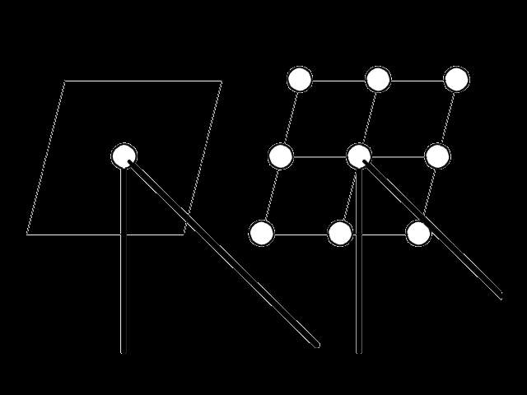
Principles behind the Area light
The (Principles behind the Area light) picture helps to understand how the soft shadows are simulated.
(a) is the Area light as defined in Bforartists. If its shape is Square, then the softness of the shadow is defined by the number of light Samples in each direction of the shape. For example, (b) illustrates the equivalent case of an Area light (Square shape), with Samples set at 3 on the Shadow and Spot panel.
The Area lamp is then considered as a grid with a resolution of three in each direction, and with a light “dupliverted” at each node for a total of nine lights.
In case (a), the energy (E) is E/1, and in case (b), the energy of each individual pseudo-light is equal to E/ (Nbr of lights). Each pseudo-light produces a faint shadow (proportional to its energy), and the overlay of the shadows produces the soft shadow (it is darker where the individual shadows overlap, and lighter everywhere else).

Hints
You will note that changing the Size parameter of your area lamp doesn’t affect the lighting intensity of your scene. On the other hand, rescaling the lamp using the S in the 3D View could dramatically increase or decrease the lighting intensity of the scene. This behavior has been coded this way so that you can fine tune all your light settings and then decide to scale up (or down) the whole scene without suffering from a drastic change in the lighting intensity. If you only want to change the dimensions of your Area lamp, without messing with its lighting intensity, you are strongly encouraged to use the Size button(s) instead.
If your computer isn’t very fast, when using the Constant Jittered sample generator method, you could find it useful to set a low Samples value (like 2) and activate Umbra, Dither, and/or Jitter in order to simulate slightly softer shadows. However, these results will never be better than the same lighting with high Samples values.

Hemi Lamp

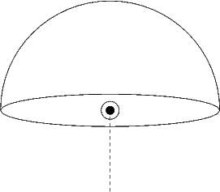
Hemi light conceptual scheme
The Hemi lamp provides light from the direction of a 180- hemisphere,
designed to simulate the light coming from a heavily clouded or otherwise uniform sky. In other words, it is a light which is shed, uniformly, by a glowing dome surrounding the scene.
Similar to the Sun lamp, the Hemi ‘s location is unimportant, while its orientation is key.
The Hemi lamp is represented with four arcs, visualizing the orientation of the hemispherical dome, and a dashed line representing the direction in which the maximum energy is radiated, the inside of the hemisphere.

Options
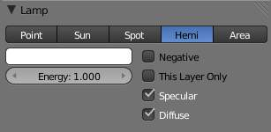
Hemi lamp’s panel
Energy and Color
These settings are common to most types of lamps, and are described in Light Properties.
Layer, Negative, Specular, and Diffuse
These settings control what the lamp affects, as described in What Light Affects.
The Hemi lamp has no light falloff settings: it always uses a constant attenuation (i.e. no attenuation).
Since this lamp is the only lamp which cannot cast any shadow, the Shadow panel is absent.

Sun

A Sun lamp provides light of constant intensity emitted in a single direction. A Sun lamp can be very handy for a uniform clear daylight open-space illumination. In the 3D view, the Sun light is represented by an encircled black dot with rays emitting from it, plus a dashed line indicating the direction of the light.
This direction can be changed by rotating the Sun lamp, like any other object, but because the light is emitted in a constant direction, the location of a Sun lamp does not affect the rendered result (unless you use the “sky & atmosphere” option).
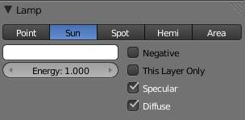
Sun lamp panel

Lamp options
Energy and Color
These settings are common to most types of lamps, and are described in Light Properties.
Negative, This Layer Only, Specular, and Diffuse
These settings control what the lamp affects, as described in What Light Affects.
The Sun lamp has no light falloff settings: it always uses a constant attenuation (i.e. no attenuation!).

Sky & Atmosphere
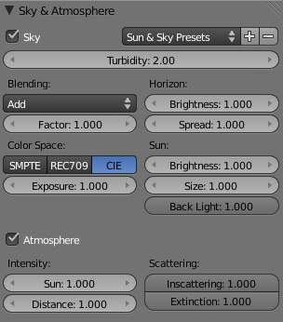
Sky & Atmosphere panel
Various settings for the appearance of the sun in the sky, and the atmosphere through which it shines, are available. For details, see Sky and Atmosphere.

Shadow
Shadow panel
The Sun light source can only cast ray-traced shadows. It shares with other lamp types the same common shadowing options, described in Shadows Properties.
The ray-traced shadows settings of this lamp are shared with other lamps, and are described in Raytraced Properties.

Raytraced Shadows

Shadow panel
The Sun light source can only cast raytraced shadows. It shares with other lamp types the same common shadowing options, described in Shadows Properties.
The raytraced shadows settings of this lamp are shared with other ones, and are described in Raytraced Properties.

Sun: Sky & Atmosphere

Sky & Atmosphere panel
This panel allows you to enable an effect that simulates various properties of real sky and atmosphere: the scattering of sunlight as it crosses the kilometers of air overhead. For example, when the Sun is high, the sky is blue (and the horizon, somewhat whitish). When the Sun is near the horizon, the sky is dark blue/purple, and the horizon turns orange. The dispersion of the atmosphere is also more visible when it is a bit foggy: the farther away an object is, the more “faded” in light gray it is... Go out into the countryside on a nice hot day, and you will see.
To enable this effect, you have to use a Sun light source. If, as usual, the position of the lamp has no importance, its rotation is crucial: it determines which hour it is. As a starting point, you should reset rotation of your Sun (with Alt-R, or typing 0 in each of the three Rotation fields X / Y / Z in the Transform Properties panel - N). This way, you’ll have a nice mid-day sun (in the tropics).
Now, there are two important angles for the Sky/Atmosphere effect: the “incidence” angle (between the light direction and the X-Y plane), which determines the “hour” of the day (as you might expect, the default rotation - straight down - is “mid-day”, a light pointing straight up is “midnight”, and so on...). And the rotation around the Z axis determines the position of the sun around the camera.
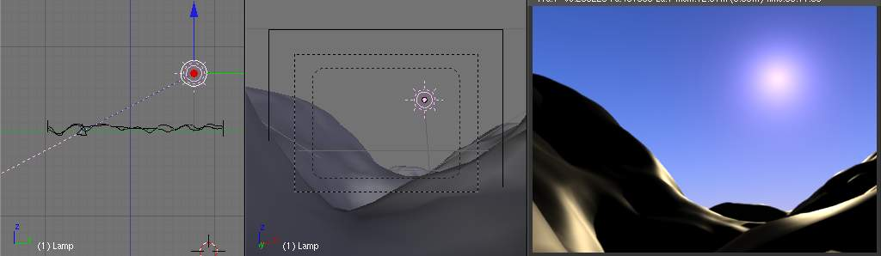
The dashed “light line” of the Sun lamp crossing the camera focal point.
In fact, to have a good idea of where the sun is in your world, relative to the camera in your 3D view, you should always try to have the dashed “light line” of the lamp crossing the center of the camera (its “focal” point), as shown in (The dashed “light line” of the Sun lamp crossing the camera focal point). This way, in camera view (Numpad0, center window in the example picture), you will see where the “virtual” sun created by this effect will be.
It is important to understand that the position of the sun has no importance for the effect: only its orientation is relevant. The position just might help you in your scene design.

Options
Sun & Sky Presets:
- Classic
- Desert
- Mountain

Sky
Sky
This button enables the sky settings: it will create a “sky”, with a “sun” if visible, and mix it with the background as defined in World settings.
Turbidity
This is a general parameter that affects sun view, sky and atmosphere; it’s an atmosphere parameter where low values describe clear sky, and high values shows more foggy sky. In general, low values give a clear, deep blue sky, with “little” sun; high values give a more reddish sky, with a big halo around the sun. Note that this parameter is one which can really modify the “intensity” of the sun lighting. See examples below.
Here are its specific controls:
Blending
The first drop-down list shows you a menu of various mix methods. The one selected will be used to blend the sky and sun with the background defined in the World settings. The mixing methods are the same as described e.g. in the Mix Compositing Node page.
Factor
Controls how much the sky and sun effect is applied to the World background.
Color space
These buttons allows you to select which color space the effect uses, with the following choices:
- CIE
- REC709
- SMPTE
- Exposure
This numeric field allows you to modify the exposure of the rendered Sky and Sun (0.0 for no correction).
Horizon
Brightness
Controls brightness of colors at the horizon. Its value should be in the range 0.0 to 10.0; values near zero means no horizontal brightness, and large values for this parameter increase horizon brightness. See examples below.
Spread
Controls spread of light at the horizon. Its value should be in the range 0.0 to 10.0; values low in the range result in less spread of light at horizon, and values high in the range result in horizon light spread in through all the sky.
Sun
Brightness
Controls the sun brightness. Its value should be in the range 0.0 to 10.0; with low values the sky has no sun and with high values the sky only has sun.
Size
Controls the size of sun. Its values should be in the range 0.0 to 10.0, but note that low values result in large sun size, and high values result in small sun size. Note that the overall brightness of the sun remains constant (set by Brightness), so the larger the sun (the smaller Size), the more it “vanishes” in the sky, and vice versa.
Back Light
For “Back Scatter Light”, result on sun’s color, high values result in more light around the sun. Its values range is -1.0 to 1.0. Negative values result in less light around sun.

Atmosphere
Atmosphere
This button enables the atmosphere settings. It will not modify the background, but it tries to simulate the effects of an atmosphere: scattering of the sunlight in the atmosphere, its attenuation, ...
Intensity
Sun
Sets sun intensity. Its values are in range 0.0 to 10.0. High values result in bluer light on far objects.
Distance
This factor is used to convert Bforartists units into an understandable unit for atmosphere effect, it starts from 0 and high values result in more yellow light in the scene.
Scattering
Inscattering
This factor can be used to decrease the effect of light inscattered into atmosphere between the camera and objects in the scene. This value should be 1.0 but can be changed to create some nice, but not realistic, images.
Extinction
This factor can be use to decrease the effect of extinction light from objects in the scene. Like Inscattering factor, this parameter should be 1.0 but you can change it; low values result in less light extinction. Its value is in the range 0.0 to 1.0.

Examples
First, let’s see what happens when we modify the orientation of the sun:

Variations in Sun orientation, Sun Size to 5.0, all other settings to default.
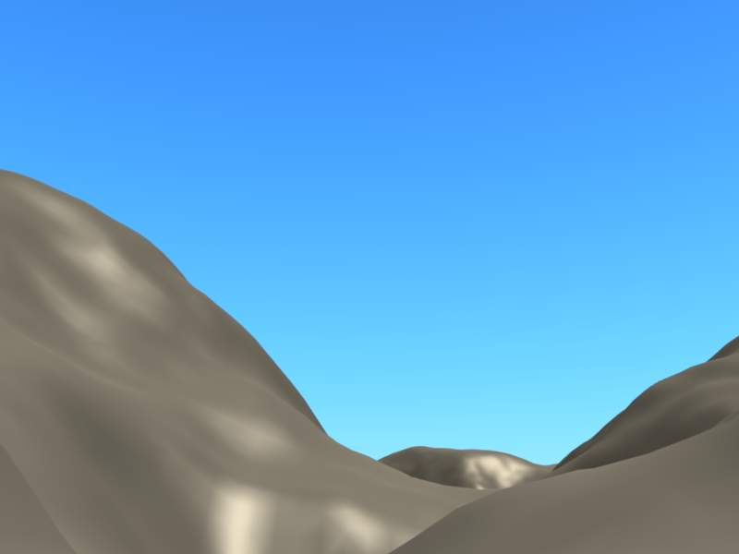  With sun right overhead (mid-day). | 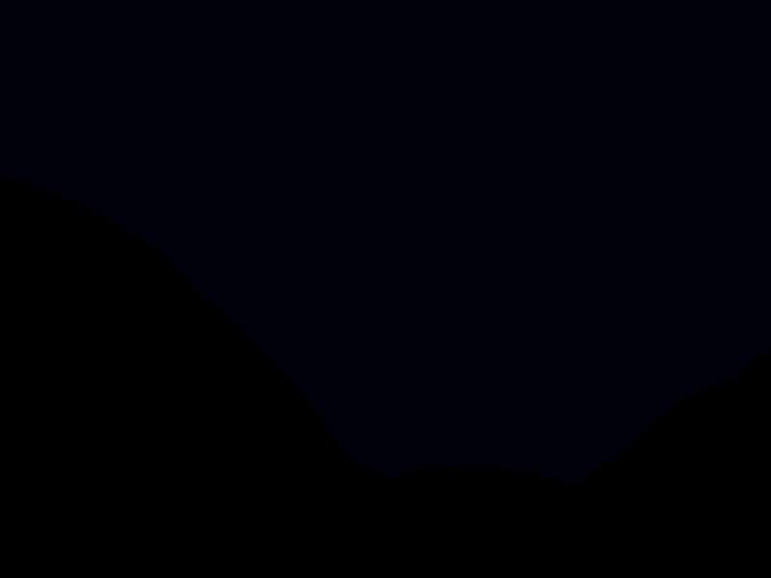  With sun deep “under the Earth” (midnight).
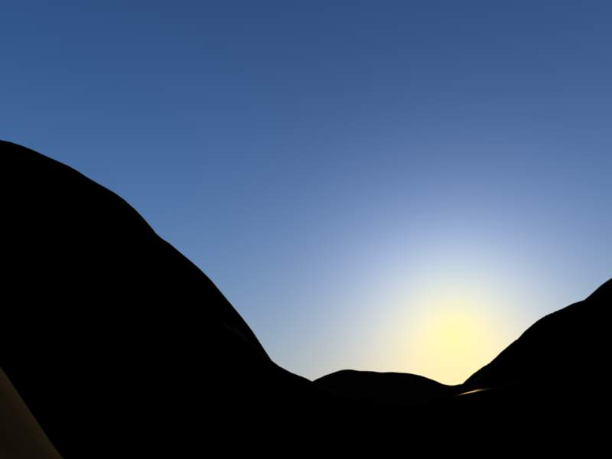  Sun slightly above the horizon (start of twilight). | 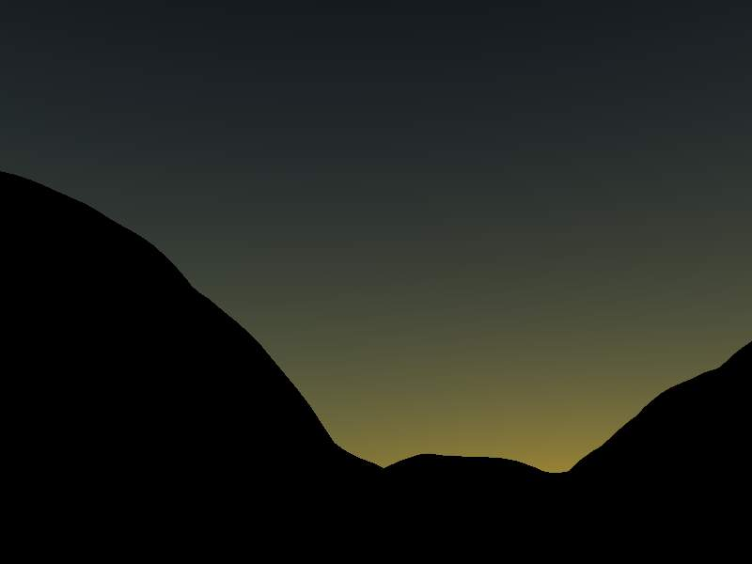  Sun slightly below the horizon (end of twilight).
The 2.4 .blend file of these examples.
And now, the effects of various settings (examples created with this 2.4 .blend file):

Variations in Turbidity parameter, all other settings to default.
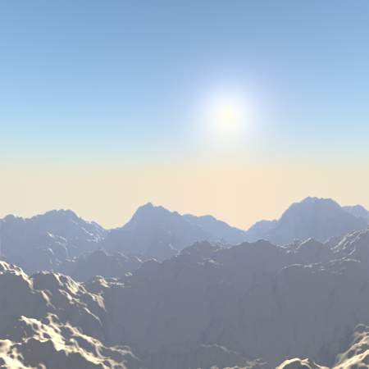  Turbidity: 2.0. | 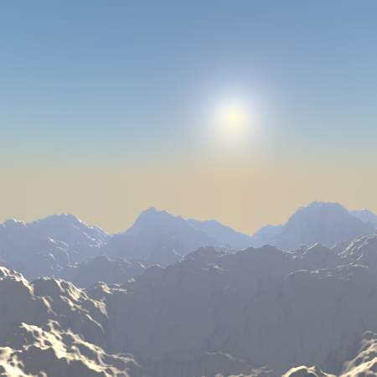  Turbidity: 2.3.
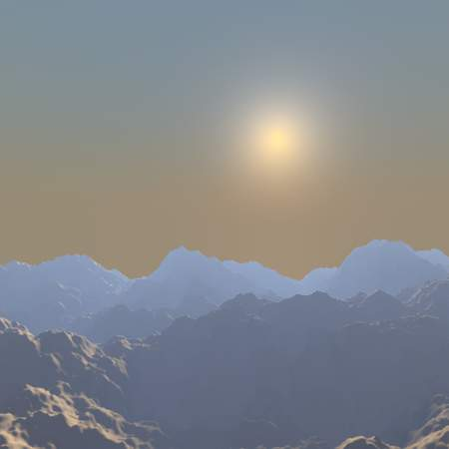  Turbidity: 5.0. | 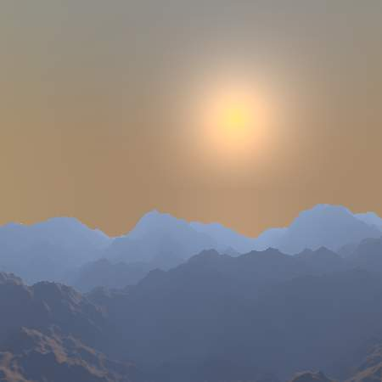  Turbidity: 10.0.

Sky

Variations in Horizon Brightness parameter, all other settings to default.
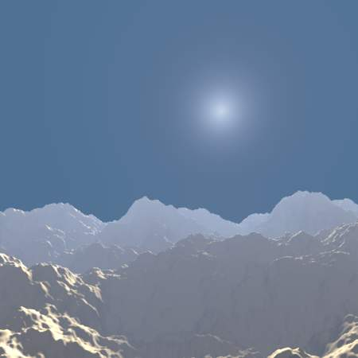  Horizon Brightness: 0.0. | 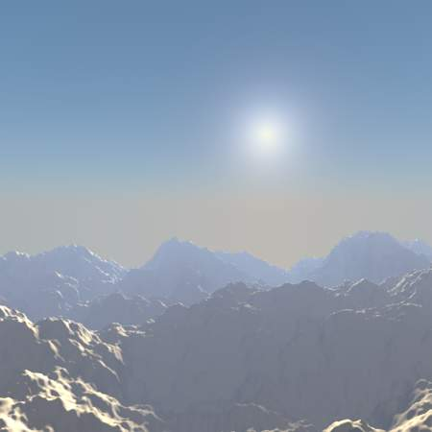  Horizon Brightness: 0.85.
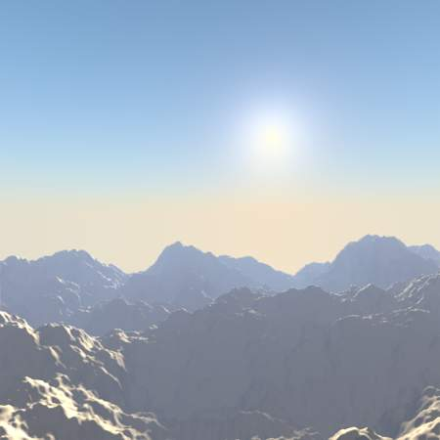  Horizon Brightness: 1.04. | 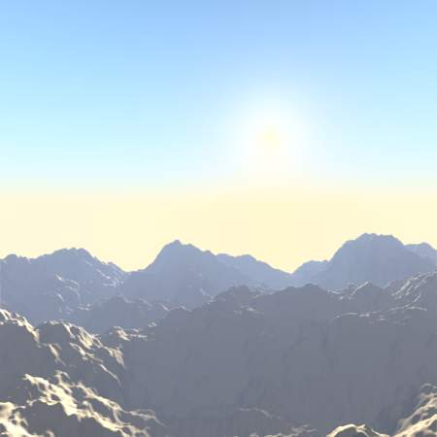  Horizon Brightness: 1.13.

Variations in Horizon Spread parameter, all other settings to default.
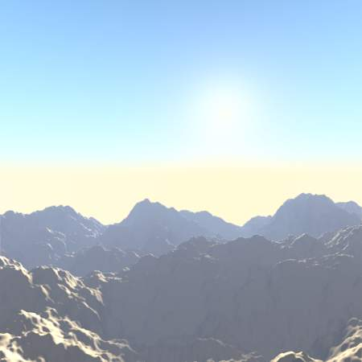  Horizon Spread: 0.7. | 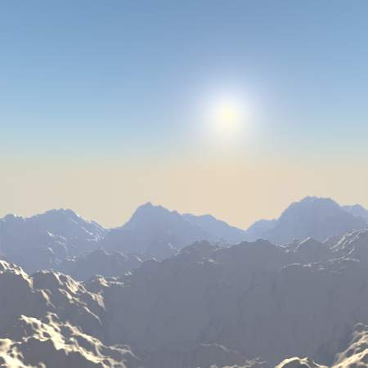  Horizon Spread: 1.2.
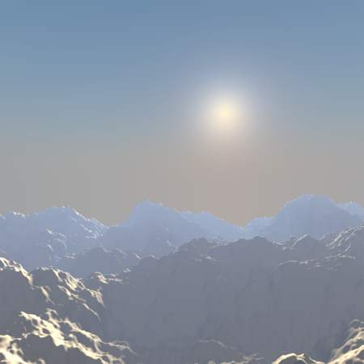  Horizon Spread: 2.2. | 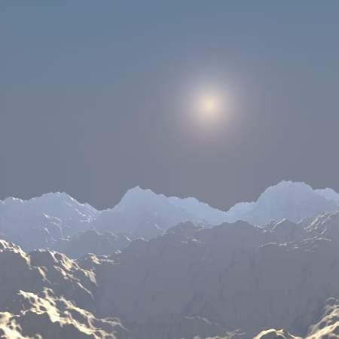  Horizon Spread: 5.0.

Variations in Sun Brightness parameter, all other settings to default.
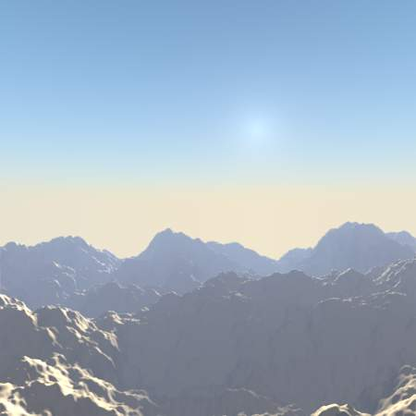  Sun Brightness: 0.2. | 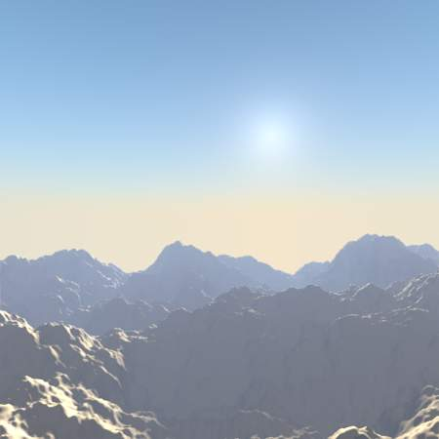  Sun Brightness: 0.5.
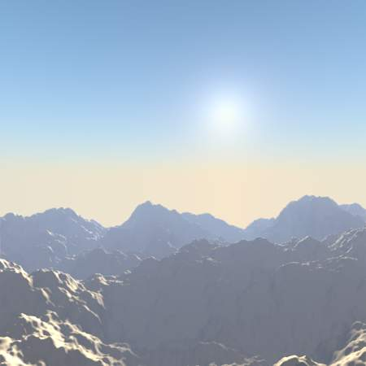  Sun Brightness: 0.75. | Sun Brightness: 1.0.

Variations in Sun Size parameter, all other settings to default.
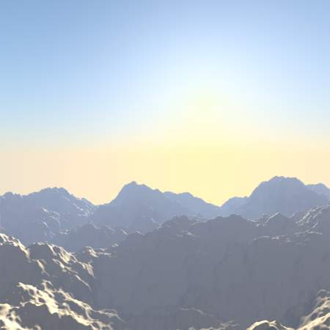  Sun Size: 2.0. | 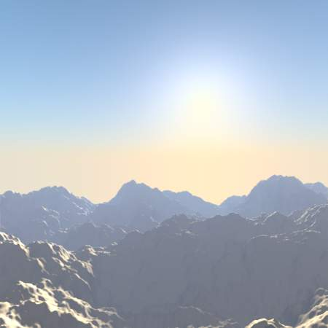  Sun Size: 4.0.
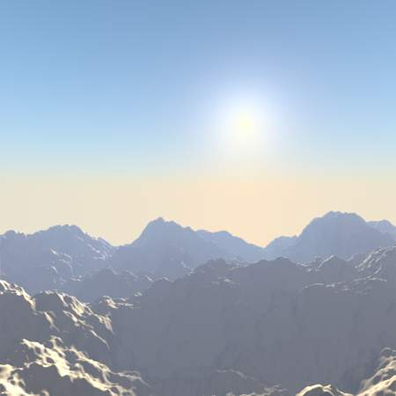  Sun Size: 7.0. | 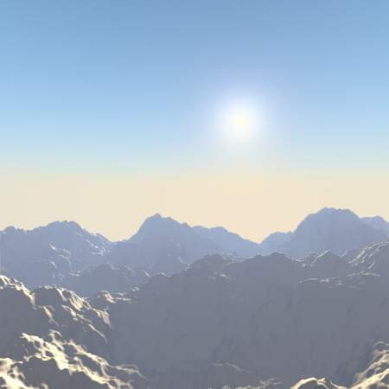  Sun Size: 10.0.

Variations in Back Light parameter, Sun Bright to 2.5, all other settings to default.
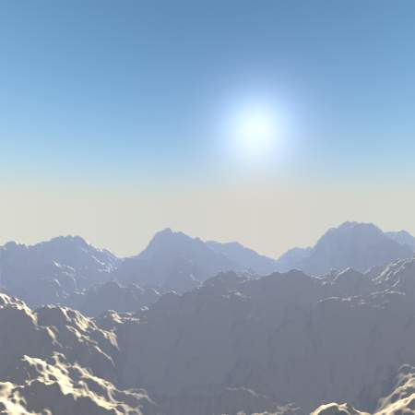  Back Light: -1.0. | 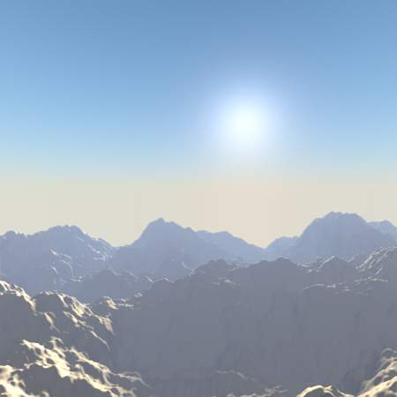  Back Light: -0.33.
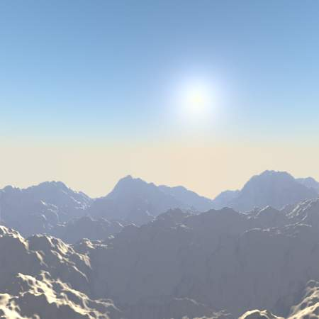  Back Light: 0.33. | Back Light: 1.0.

Atmosphere
For all renders below, Hor.Bright is set to 0.2, and Sun Bright to 2.0.

Variations in Sun Intensity parameter, all other settings to default.
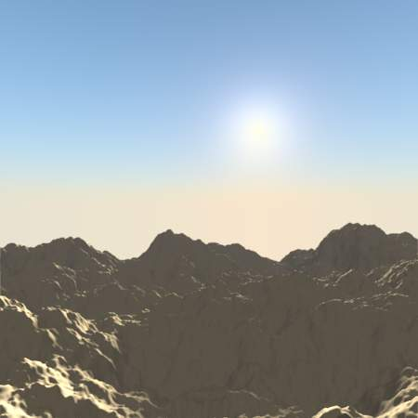  Sun Intensity: 1.0. | 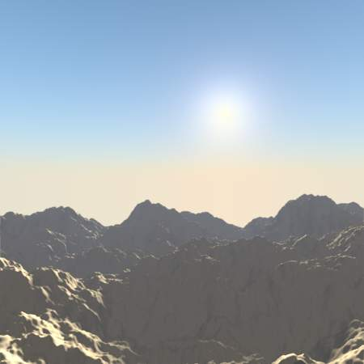  Sun Intensity: 3.33.
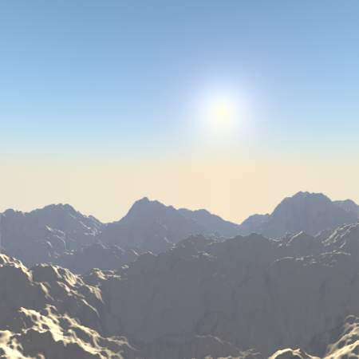  Sun Intensity: 6.66. | Sun Intensity: 10.0.

Variations in Inscattering parameter, all other settings to default.
Inscattering: 0.1. | 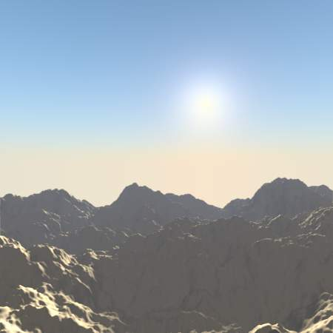  Inscattering: 0.33.
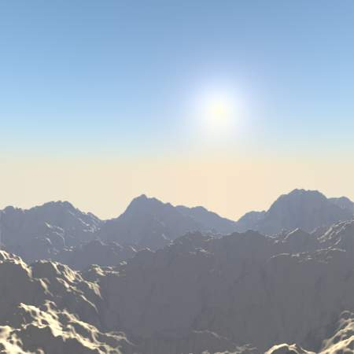  Inscattering: 0.66. | Inscattering: 1.0.

Variations in Extinction parameter, all other settings to default.
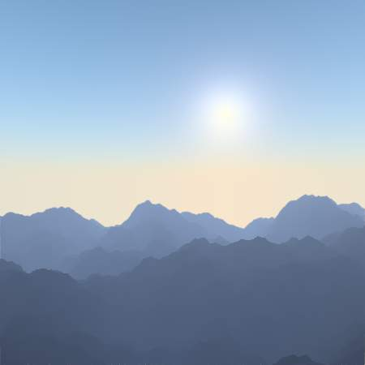  Extinction: 0.0. | 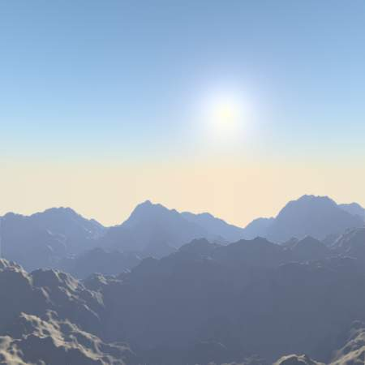  Extinction: 0.33.
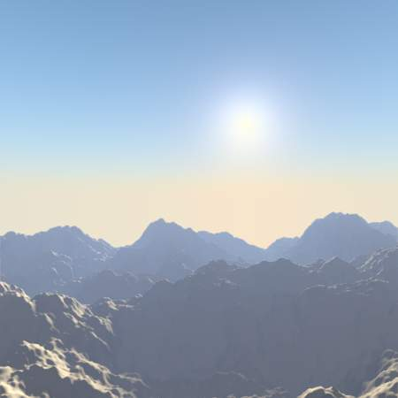  Extinction: 0.66. | Extinction: 1.0.

Variations in Distance parameter, all other settings to default.
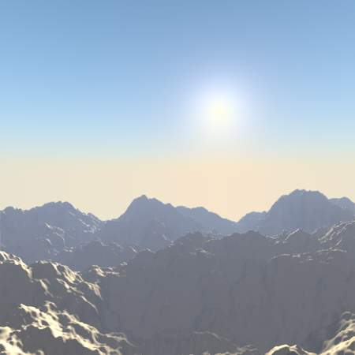  Distance: 1.0. | 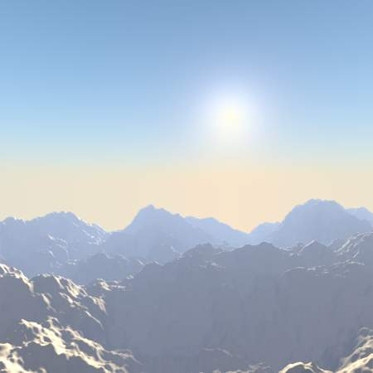  Distance: 2.0.
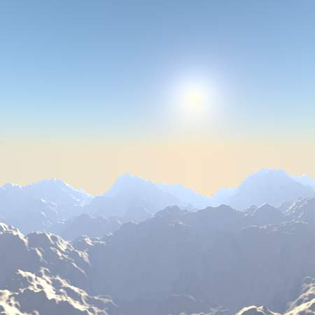  Distance: 3.0. | 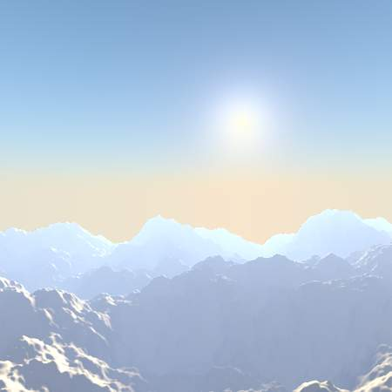  Distance: 4.0.

Hints and limitations
To always have the Sun pointing at the camera center, you can use a TrackTo constraint on the sun object, with the camera as target, and -Z as the “To” axis (use either X or Y as “Up” axis). This way, to modify height/position of the sun in the rendered picture, you just have to move it; orientation is automatically handled by the constraint. Of course, if your camera itself is moving, you should also add e.g. a Copy Location constraint to your Sun lamp, with the camera as target - and the Offset option activated... This way, the sun light won’t change as the camera moves around.
If you use the default Add mixing type, you should use a very dark-blue world color, to get correct “nights”...
This effect works quite well with a Hemi lamp, or some ambient occlusion, to fill in the Sun shadows.
Atmosphere shading currently works incorrectly in reflections and refractions and is only supported for solid shaded surfaces. This will be addressed in a later release.

Lighting Rigs
A rig is a standard setup and combination of objects; there can be lighting rigs, or armature rigs, etc. A rig provides a basic setup and allows you to start from a known point and go from there. Different rigs are used for different purposes and emulate different conditions; the rig you start with depends on what you want to convey in your scene. Lighting can be very confusing, and the defaults do not give good results. Further, very small changes can have a dramatic effect on the mood and colors.
In all the lighting rigs, the default camera is always positioned nearly 15 degrees off dead-on, about 25 BU (Bforartists Units) back and 9 BU to the side of the subject, at eye level, and uses a long lens (80mm). Up close, a 35mm lens will distort the image. A long lens takes in more of the scene. A dead-on camera angle is too dramatic and frames too wide a scene to take in. So now you know; next time you go to a play, sit off-center and you won’t miss the action happening on the sidelines and will have a greater appreciation for the depth of the set. Anyway, enough about camera angles; this is about lighting.

Environment or Ambient Only
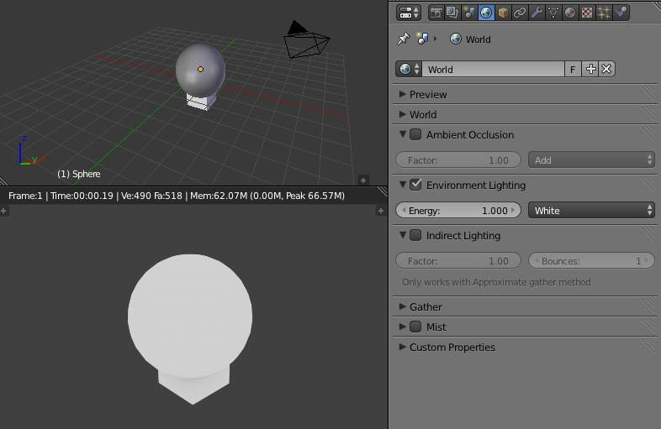
Environment (Ambient) lighting only.
In the World context, there is a panel Environment Lighting, where you enable environment or ambient lighting of your scene. Ambient light is the scattered light that comes from sunlight being reflected off every surface it hits, hitting your object, and traveling to camera.
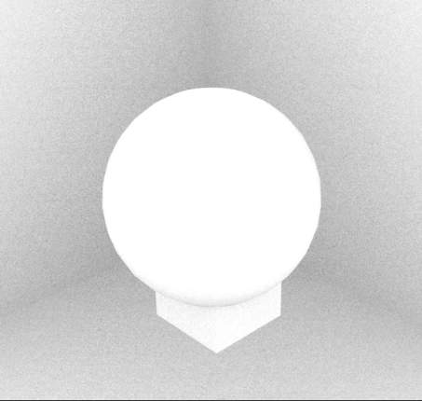
Ambient occlusion.
Ambient light illuminates, in a perfectly balanced, shadeless way, without casting shadows. You can vary the intensity of the ambient light across your scene via ambient occlusion. The ambient color is a sunny white.

Single Rig
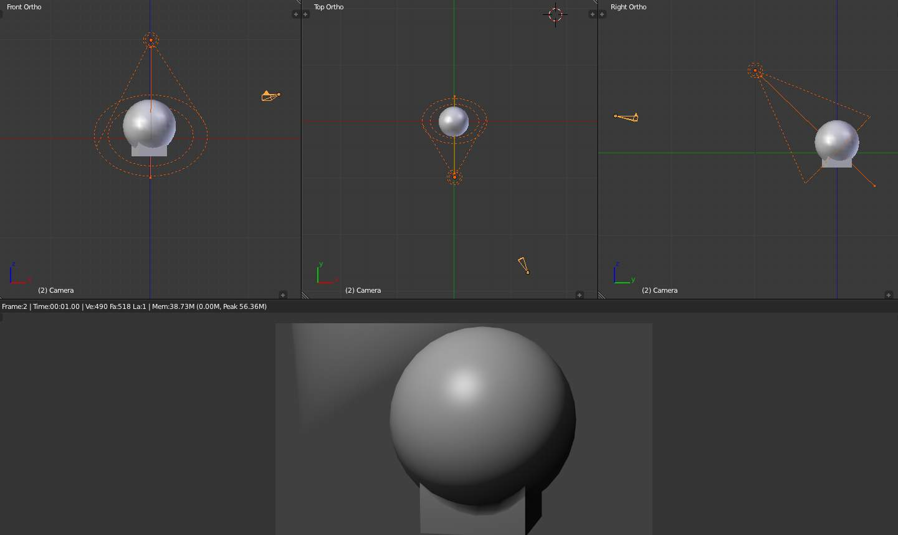
Standard Spot light rig.
The sole, or key, spot light rig provides a dramatic, showy, yet effective illumination of one object or a few objects close together. It is a single Spot light, usually with a hard edge. Halos are enabled in this render to remind you of a smoky nightclub scene. It is placed above and directly in front of the subject; in this case 10 BU in front and 10 BU high, just like a stage, it shines down at about a 40 degrees angle. We use quadratic attenuation.
You can make the spot wider by increasing Size Spot Shape and softening the edge by increasing Blend Spot Shape, and parent it to the main actor, so that the spot follows him as he moves around. Objects close to the main actor will naturally be more lit and your viewer will pay attention to them.
Moving this spot directly overhead and pointing down gives the interrogation effect. At the opposite end of the show-off emotional spectrum is one soft candlelight (Point lamp, short falloff Distance, yellow light) placed really up close to the subject, dramatizing the fearful “lost in the darkness” effect.
Somewhere in the macabre spectrum is a hard spot on the floor shining upward. For fun, grab a flashlight, head into the bathroom and close the door. Turn out the light and hold the flashlight under your chin, pointing up. Look in the mirror and turn it on. Ghoulies! Don’t blame me for nightmares, and I hope you get the point: lighting, even with a single light, varying the intensity, location and direction, changes everything in a scene.
Use this rig, with Environment Lighting light (and props receiving and being lit by ambient light in their material settings) for scenes that feature one main actor or a product being spotlighted. Do not use this rig for big open spaces or to show all aspects of a model.

Two-Point Rig
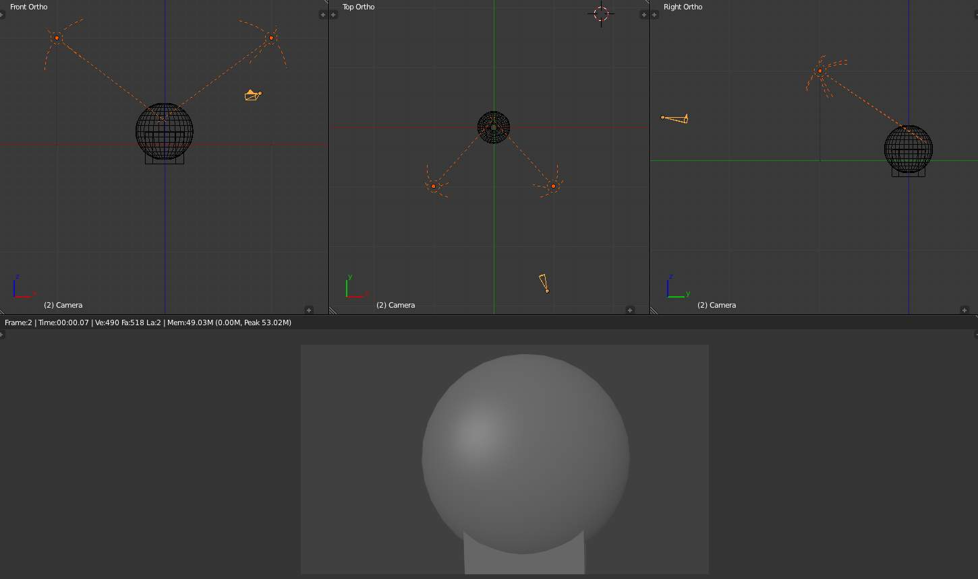
Standard two-point light rig.
The two-point lighting rig provides a balanced illumination of an object. Shown to the right are the views of the standard two-point lighting rig. It is called the two-point because there are two points of light. The standard two-point lighting rig provides a balanced illumination of untextured objects hanging out there in 3D space. This rig is used in real studios for lighting a product, especially a glossy one.
Both lights are almost the same but do different things. Both emulate very wide, soft light by being Hemi. In real life, these lights bounce light off the inside of a silver umbrella.
Notice how we use low Energy to bring out the dimensionality of the sphere; I can’t stress that enough. Hard, bright lights actually flatten it and make you squint. Soft lights allow your eye to focus. We disable specular for right Hemi, so we don’t get that shiny forehead or nose.
The lamp on the left however, lets it be known that it is there by enabling specular; specular flare is that bright spot that is off center above midline on the sphere.
Use this rig to give even illumination of a scene, where there is no main focus. The Hemi ‘s will light up background objects and props, so Environment Lighting is not that important. At the opposite end of the lighting spectrum, two narrow Spot lights at higher power with a hard edge gives a “This is the Police, come out with your hands up” kind of look, as if the subject is caught in the crossfire.

Three-Point Rigs
The standard three-point lighting rig is the most common illumination of objects and scenes bar none. If you want to show off your model, use this rig. As you can see, the untextured unmaterialized sphere seems to come out at you. There are multiple thesis on this rig, and you will use one of two:
- Studio - used in a real studio to film in front of a green screen or backdrop. Use this rig when you are rendering your CG objects to alpha into the scene so that the lighting on the actors and your CG objects is the same.
- Standard - used in real life to light actors on a set, and gives some backlighting to highlight the sides of actors, making them stand out more and giving them depth.

Studio rig
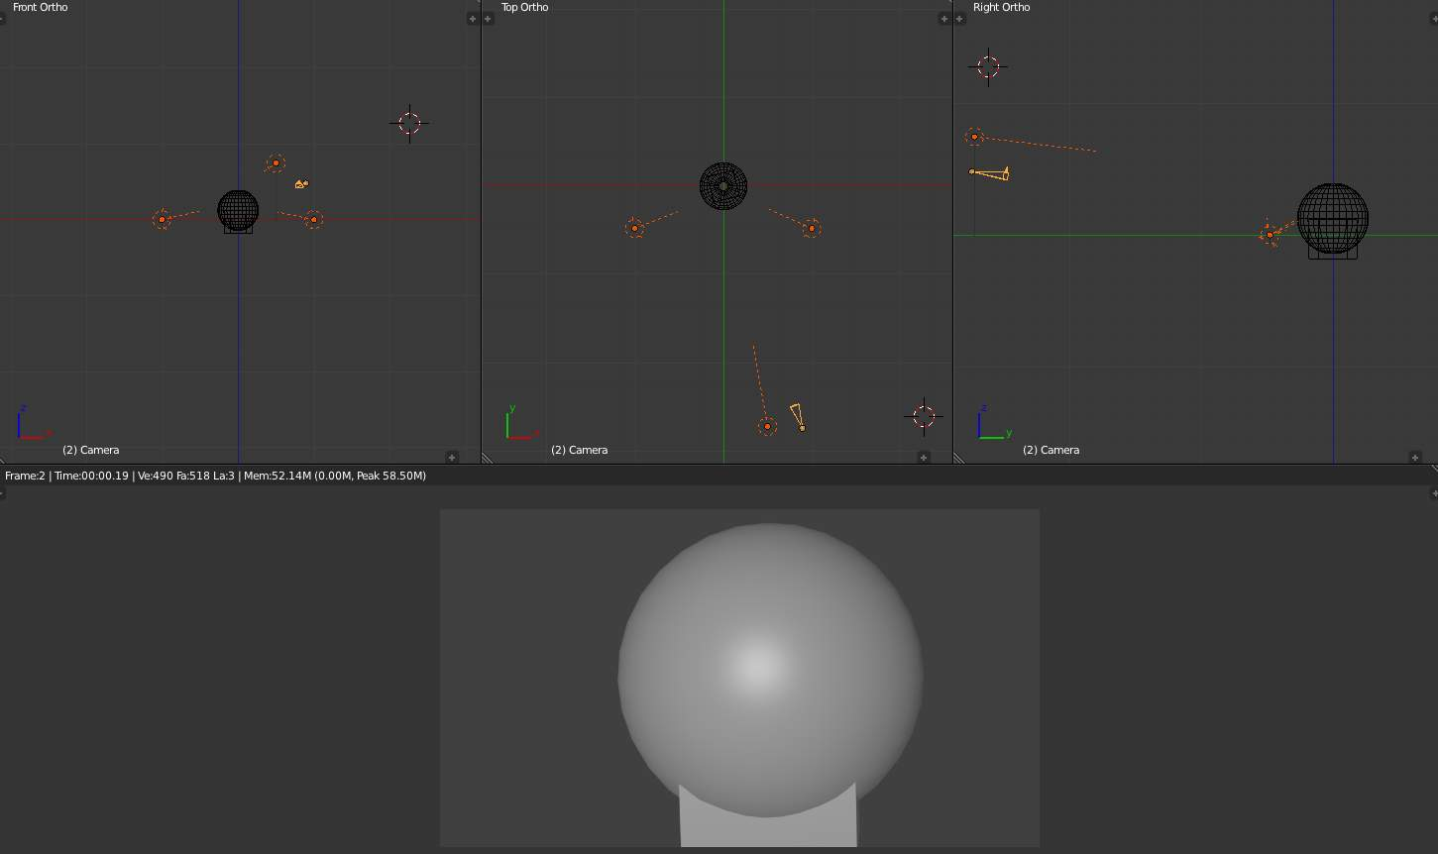
Studio three-point light rig.
Shown to the right are the “Studio” top, front, and side views of the standard three-point lighting rig. It changes the dynamics of the scene, by making a brighter “key” light give some highlights to the object, while two side “fill” lights soften the shadows created by the key light.
In the studio, use this rig to film a talking head (actor) in front of a green screen, or with multiple people, keeping the key light on the main actor. This rig is also used to light products from all angles, and the side fill lights light up the props.
The key light is the Area light placed slightly above and to the left of the camera. It allows the specular to come out. It is about 30 BU back from the subject, and travels with the camera. A little specular shine lets you know there’s a light there, and that you’re not looking at a ghost. In real life, it is a spot with baffles, or blinders, that limit the area of the light.
The two sidelights are reduced to only fill; each of them are Hemi lights placed 20 BU to the side and 5 BU in front of the subject, at ground level. They don’t cause a spotshine on the surface by disabling specular, and at ground level, light under the chin or any horizontal surfaces, countering the shadows caused by the key light.
Use this rig to give balanced soft lighting that also highlights your main actor or object. It combines the best of both the single rig and the two-point rig, providing balanced illumination and frontal highlights. For a wide scene, you may have to pull the sidelights back to be more positioned like the two-point rig.

Standard Rig
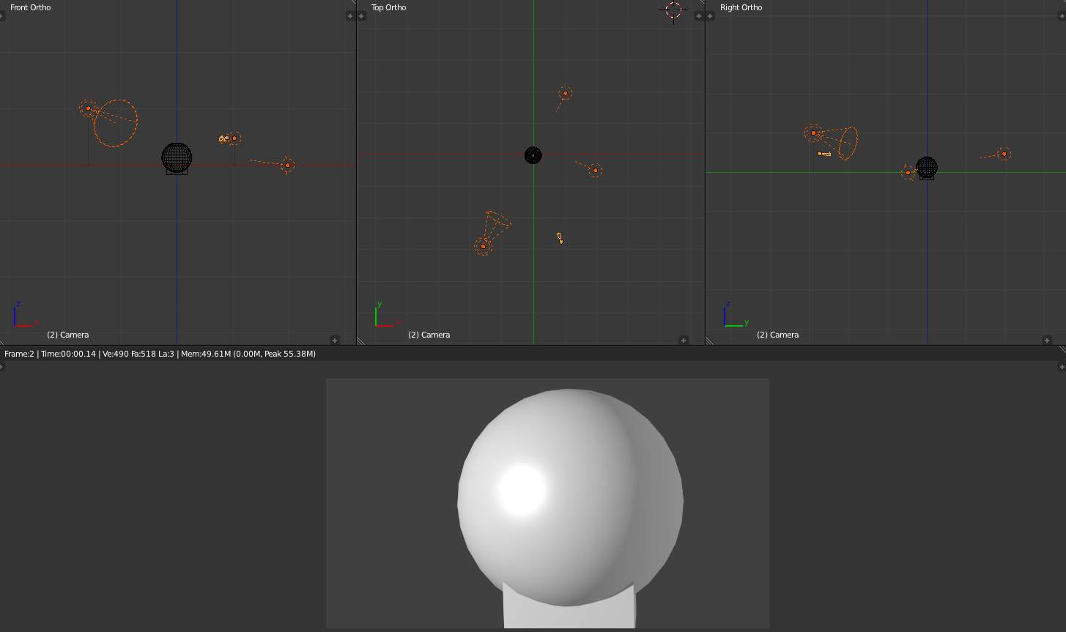
Standard three-point light rig.
Without a curtain in back of your main subject, you have depth to work with. The left fill light has been moved behind the subject (so it is now called a backlight) and is just off-camera, while the right side fill light remains the same. The keylight gives you specular reflection so you can play with specularity and hardness in your object’s material settings. The key light gives that “in-the-spotlight” feel, highlighting the subject, while the backlight gives a crisp edge to the subject against the background. This helps them stand out.
In this rig, the key light is a fairly bright spot light. Use a slighter tinge of yellow because the light is so bright; it is the only light for that side. The other sidelight has been moved in back and raised to eye (camera) level. You need to cut the energy of the backlight in half, or when it is added to the remaining sidelight, it will light up the side too much and call too much attention to itself. You can vary the angle and height of the backlight to mimic a sun lighting up the objects.
Use this rig in normal 3D animations to light the main actor. Use this rig especially if you have transparent objects (like glass) so that there is plenty of light to shine through them to the camera. The tricky part here is balancing the intensities of the lights so that no one light competes with or overpowers the others, while making sure all three work together as a team.

Four-point Rig
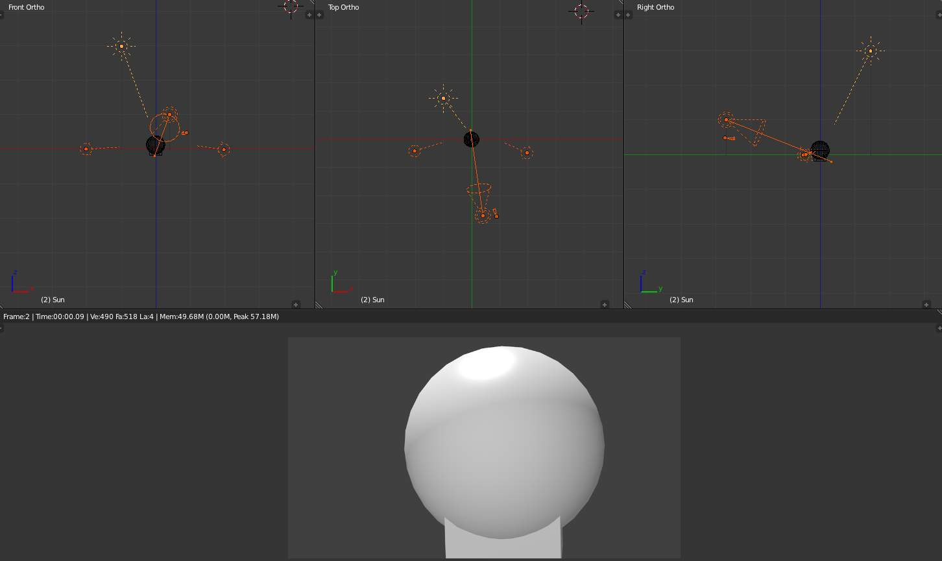
Four-point light rig.
The four-point lighting rig provides a better simulation of outside lighting, by adding a Sun lamp 30 Bforartists Units above, 10 to the side, and 15 BU behind the subject. This sunlight provides backlighting and fills the top of the subject; even producing an intentional glare on the top of their head, telling you there is a sun up there. Notice it is colored yellow, which balances out the blue sidelights.
Changing the key light to a Spot, select Inverse Square, disable Specular and pure white light combines with and softens the top sun flare while illuminating the face, resulting in a bright sunshine effect. Two lights above means sharper shadows as well, so you might want to adjust the side fill lights. In this picture, they are still Hemi, disable Specular.
Use this rig when the camera will be filming from behind the characters, looking over their shoulder or whatnot, because the sun provides the backlight there. Also use this rig when you have transparent objects, so there is light to come through the objects to the camera.
Another spot for the fill light is shining up onto the main actor’s face, illuminating the underside of his chin and neck. This gets rid of a sometimes ugly shadow under the chin, which if not corrected, can make the actor look fat or like they have a double chin; otherwise distracting. It evens out the lighting of the face.

Troubleshooting
If you run into a problem with your render, where there are really bright areas, or really dark ones, or strange shadows, or lines on your objects, here is what I suggest you do:
- First, try deactivating all materials (create a default, gray one, and enter its name in the Mat field, Layer panel, Render Layers context - to get back all your normal materials, just erase this text field!). See if you get those problems with just grayness objects. If you don’t have the problem anymore, that should tell you that you’ve got a materials-interacting-with-light problem. Check the material settings, especially ambient, reflection and all those little buttons and sliders in the Material context. You can set some lights to affect only certain materials, so if there’s an issue with only a few objects being really bright, start with those.
- Then start “killing” lights (e.g. moving them to an unused layer); regress all the way back to one light, make sure it’s smooth, then add them in one by one. As they add together, reduce power in the tested ones so they merge cleanly, or consider not adding it at all, or, especially, reduce the energy of the lamp you just introduced.
- You can also set lights to only light objects on a layer, so again, if some of the gray spheres have weirdness, check for that as well. Again, you may have done some of this accidentally, so sometimes deleting the light and re-adding it with defaults helps you reset to a known-good situation.
- Negative lights can be very tricky, and make your model blotchy, so pay special attention to your use of those special lights. Shadow-only lights can throw off the look of the scene as well. Overly textured lights can make your scene have random weird colors. Don’t go too far off a slight tinge of blue or yellow or shades of white, or your material may show blue in the Material context but render green, and you will be very confused.
- Look at your environment settings World context: Horizon, Zenith, and Environment Lighting.

Environment Lighting

Environment light provides light coming from all directions.
Light is calculated with a ray-traced method which is the same as that used by Ambient Occlusion. The difference is that Environment lighting takes into account the “ambient” parameter of the material shading settings, which indicates the amount of ambient light/color that that material receives.
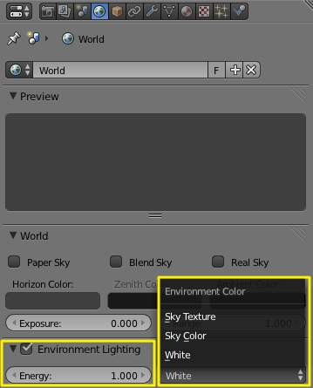
Environment Lighting panel.
Also, you can choose the environment color source (white, sky color, sky texture) and the light energy.
Energy
Defines the strength of environment light.
Environment Color
Defines where the color of the environment light comes from.
Using both settings simultaneously produces better global lighting.
It’s good for mimicking the sky in outdoor lighting. Environment lighting can be fairly noisy at times.

Ambient Occlusion

Ambient Occlusion is a sophisticated ray-tracing calculation which simulates soft global illumination shadows by faking darkness perceived in corners and at mesh intersections, creases, and cracks, where ambient light is occluded, or blocked.
There is no such thing as AO in real life; AO is a specific not-physically-accurate (but generally nice-looking) rendering trick. It basically samples a hemisphere around each point on the face, sees what proportion of that hemisphere is occluded by other geometry, and shades the pixel accordingly.
It’s got nothing to do with light at all; it’s purely a rendering trick that tends to look nice because generally in real life surfaces that are close together (like small cracks) will be darker than surfaces that don’t have anything in front of them, because of shadows, dirt, etc.
The AO process, though, approximates this result; it’s not simulating light bouncing around or going through things. That’s why AO still works when you don’t have any lights in the scene, and it’s why just switching on AO alone is a very bad way of “lighting” a scene.
You must have ray tracing enabled as a Render panel option in the Shading section for this to work.
You must have an ambient light color set as you desire. By default, the ambient light color (world) is black, simulating midnight in the basement during a power outage. Applying that color as ambient will actually darken all colors. A good outdoor mid-day color is RGB (0.9, 0.9, 0.8) which is a whitish yellow sunny kind of color on a bright-but-not-harshly-bright day.

Options
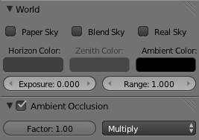
The World panel with ambient color sliders highlighted.
Factor
The strength of the AO effect, a multiplier for addition.
Ambient Occlusion is composited during the render. Two blending modes are available:
Add
The pixel receives light according to the number of non-obstructed rays. The scene is lighter. This simulates global illumination.
Multiply
Ambient occlusion is multiplied over the shading, making things darker.

Note
If Multiply is chosen, there must be other light sources; otherwise the scene will be pitch black. In the other two cases the scene is lit even if no explicit light is present, just from the AO effect. Although many people like to use AO alone as a quick shortcut to light a scene, the results it gives will be muted and flat, like an overcast day. In most cases, it is best to light a scene properly with Bforartists’s standard lamps, then use AO on top of that, set to Multiply, for the additional details and contact shadows.

The Gather panel contains settings for the ambient occlusion quality. Note that these settings also apply to Environment Lighting and Indirect Lighting.
Ambient occlusion has two main methods of calculation: Raytrace and Approximate.

Gather

Raytrace
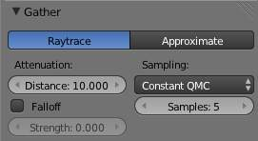
The Amb Occ panel, Raytrace method.
The Raytrace method gives the more accurate, but also the more noisy results. You can get a nearly noiseless image, but at the cost of render time... It is the only option if you want to use the colors of your sky’s texture.
Attenuation
Length of rays defines how far away other faces may be and still have an occlusion effect. The longer this distance, the greater impact that far-away geometry will have on the occlusion effect. A high Distance value also means that the renderer has to search a greater area for geometry that occludes, so render time can be optimized by making this distance as short as possible for the visual effect that you want.
Sampling
Samples
The number of rays used to detect if an object is occluded. Higher numbers of samples give smoother and more accurate results, at the expense of slower render times. The default value of 5 is usually good for previews. The actual number of rays shot out is the square of this number (i.e. Samples at 5 means 25 rays). Rays are shot at the hemisphere according to a random pattern (determined by the sample methods described above); this causes differences in the occlusion pattern of neighboring pixels unless the number of shot rays is big enough to produce good statistical data.
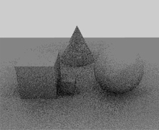  Ambient Occlusion with 3 Samples. | 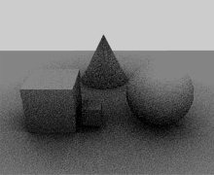  Ambient Occlusion with 6 Samples. | 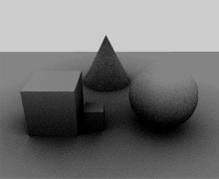  Ambient Occlusion with 12 Samples.
You have the three standard sampling options:
Constant QMC
The base Quasi-Monte Carlo, gives evenly and randomly distributed rays.
Adaptive QMC
An improved method of QMC, that tries to determine when the sample rate can be lowered or the sample skipped, based on its two settings:
Threshold
The limit below which the sample is considered fully occluded (“black”) or un-occluded (“white”), and skipped.
Adapt to Speed
A factor to reduce AO sampling on fast-moving pixels. As it uses the Vec render pass, that must also be enabled (see render passes page).

Note
About QMC
See also the raytraced shadows page for more info about the Quasi-Monte Carlo sampling method.
Constant Jittered
The historical sample method, more prone to “bias” artifacts...
Bias
The angle (in radians) the hemisphere will be made narrower (i.e. the hemisphere will no longer be a real hemisphere: its section will no longer be a semicircle, but an arc of a circle of pi - bias radians).
The bias setting allows you to control how smooth “smooth” faces will appear in AO rendering. Since AO occurs on the original faceted mesh, it is possible that the AO light makes faces visible even on objects with “smooth” on. This is due to the way AO rays are shot, and can be controlled with the Bias slider. Note that while it might even happen with QMC sampling methods, it is much more visible with the Constant Jittered one - and anyway, you have no Bias option for QMC.

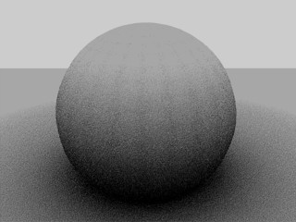  24×24 UV Sphere with Bias: 0.05 (default). Note the facets on the sphere’s surface even though it is set to smooth. | 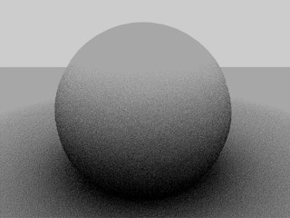  Raising the Bias to 0.15 removes the faceted artifacts.

Approximate
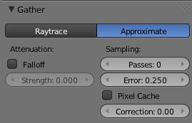
The Amb Occ panel, Approximate method.
The Approximate method gives a much smoother result for the same amount of render time, but as its name states, it is only an approximation of the Raytrace method, which implies it might produce some artifacts - and it cannot use the sky’s texture as the base color
This method seems to tend to “over-occlude” the results. You have two complementary options to reduce this problem:
Passes
Set the number of pre-processing passes, between 0 (no pre-processing) to 10. Keeping the pre-processing passes high will increase render time but will also clear some artifacts and over-occlusions.
Error
This is the tolerance factor for approximation error (i.e. the max allowed difference between approximated result and fully computed result). The lower, the slower the render, but the more accurate the results... Ranges between 0.0 and 10.0, defaults to 0.250.
Pixel Cache
When enabled, it will keep values of computed pixels to interpolate it with its neighbors. This further speeds up the render, generally without visible loss in quality...
Correction
A correction factor to reduce over-occlusion. Ranges between 0.0 (no correction) to 1.0.

Common Settings
Falloff
When activated, the distance to the occluding objects will influence the “depth” of the shadow. This means that the further away the occluding geometry is, the lighter its “shadow” will be. This effect only occurs when the Strength factor is higher than 0.0. It mimics light dispersion in the atmosphere...
Strength
Controls the attenuation of the shadows enabled with Use Falloff. Higher values give a shorter shadow, as it falls off more quickly (corresponding to a more foggy/dusty atmosphere). Ranges from 0.0 (default, no falloff) to 10.0.

Technical Details
Ambient occlusion is calculated by casting rays from each visible point, and by counting how many of them actually reach the sky, and how many, on the other hand, are obstructed by objects.
The amount of light on the point is then proportional to the number of rays which have “escaped” and have reached the sky. This is done by firing a hemisphere of shadow rays around. If a ray hits another face (it is occluded) then that ray is considered “shadow”, otherwise it is considered “light”. The ratio between “shadow” and “light” rays defines how bright a given pixel is.

Hints
Ambient occlusion is a ray-tracing technique (at least with the Raytrace method), so it tends to be slow. Furthermore, performance severely depends on octree size, see the rendering chapter for more information.

Indirect Lighting

Indirect Lighting adds indirect light bouncing of surrounding objects. It’s modes the light that is reflected from other surfaces to the current surface. Is more comprehensive, more physically correct, and produces more realistic images. It is also more computationally expensive. Take a look at the following examples of a scene lit with Direct Lighting and both Direct+Indirect Lighting:
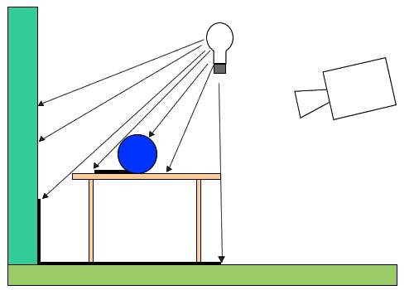
Direct Lighting Schematic.
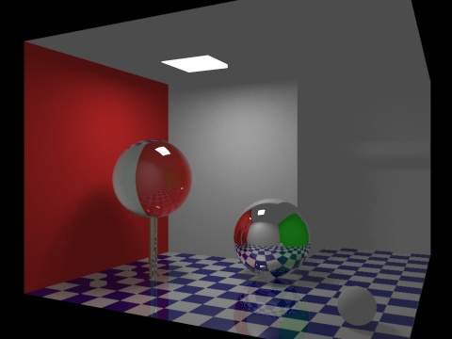
Direct Lighting Render
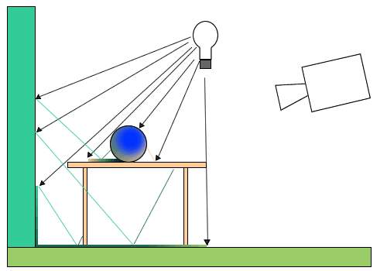
Direct+Indirect Lighting Schematic
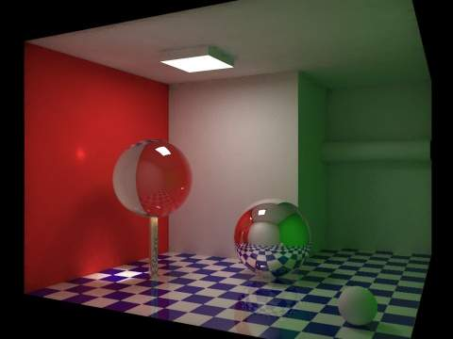
Direct+Indirect Lighting Render
Images courtesy of rastermon.com
Indirect Lighting only works with Approximate gather method.
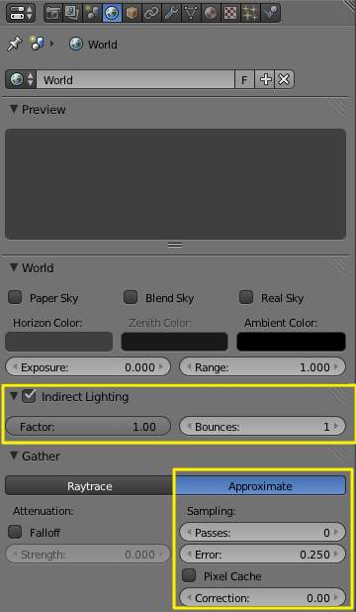
Indirect Lighting parameters.

Options
The Indirect Lighting panel contains two options:
Factor
Defines how much surrounding objects contribute to light.
Bounces
Number of indirect diffuse light bounces.
The Gather panel contains settings for the indirect lighting quality. Note that these settings also apply to Environment Lighting and Ambient Occlusion.

Approximate
The Indirect Lighting panel, Approximate method.
The Approximate method gives a much smoother result for the same amount of render time, but as its name states, it is only an approximation of the Raytrace method, which implies it might produce some artifacts - and it cannot use the sky’s texture as the base color
This method seems to tend to “over-occlude” the results. You have two complementary options to reduce this problem:
Passes
Set the number of pre-processing passes, between 0 (no pre-processing) to 10. Keeping the pre-processing passes high will increase render time but will also clear some artifacts and over-occlusions.
Error
This is the tolerance factor for approximation error (i.e. the max allowed difference between approximated result and fully computed result). The lower, the slower the render, but the more accurate the results... Ranges between 0.0 and 10.0, defaults to 0.250.
Pixel Cache
When enabled, it will keep values of computed pixels to interpolate it with its neighbors. This further speeds up the render, generally without visible loss in quality...
Correction
A correction factor to reduce over-occlusion. Ranges between 0.0 (no correction) to 1.0.

Exposure and Range

Reference
Mode: All modes
Panel: World (Shading context, World sub-context)

Description
Exposure and Range are similar to the “Color Curves” tool in Gimp or Photoshop.
These controls affect the rendered image, and the results are baked into the render. For information on achieving similar affects with render controls, see Color Management and Exposure.
Previously Bforartists clipped color directly with 1.0 (or 255) when it exceeded the possible RGB space. This caused ugly banding and overblown highlights when light overflowed (An overexposed teapot).
Using an exponential correction formula, this now can be nicely corrected.

Options
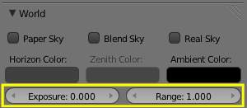
Exposure and Range sliders.
Exposure
The exponential curvature, with 0.0 being linear, and 1.0 being curved.
Range
The range of input colors that are mapped to visible colors (0.0 - 1.0).
So without Exposure we will get a linear correction of all color values:
Range` > 1.0
the picture will become darker; with Range = 2.0, a color value of 1.0 (the brightest by default) will be clipped to 0.5 (half bright) (Range : 2.0).
Range` < 1.0
the picture will become brighter; with Range = 0.5, a color value of 0.5 (half bright by default) will be clipped to 1.0 (the brightest) (Range : 0.5).

Examples
With a linear correction every color value will get changed, which is probably not what we want. Exposure brightens the darker pixels, so that the darker parts of the image won’t be changed at all (Range : 2.0, Exposure : 0.3).
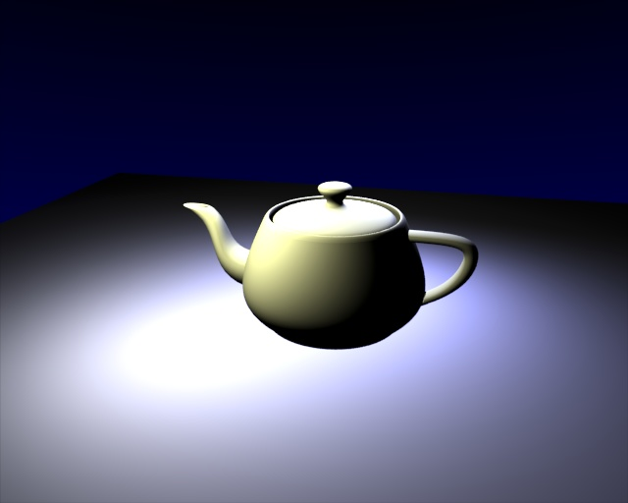  An overexposed teapot. | 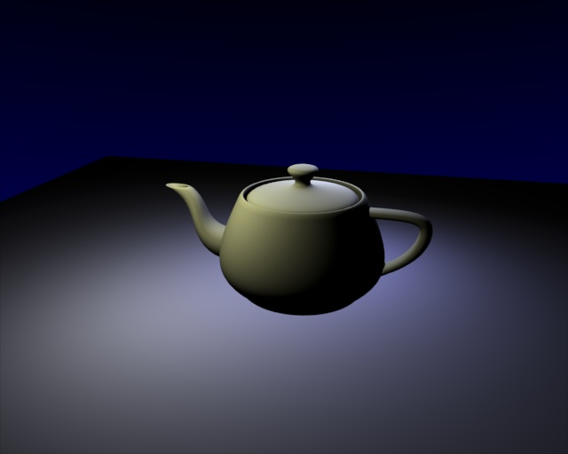  Range: 2.0.
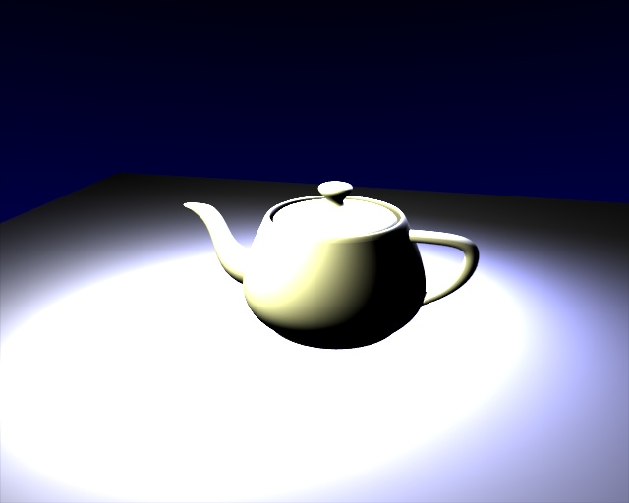  Range: 0.5. | 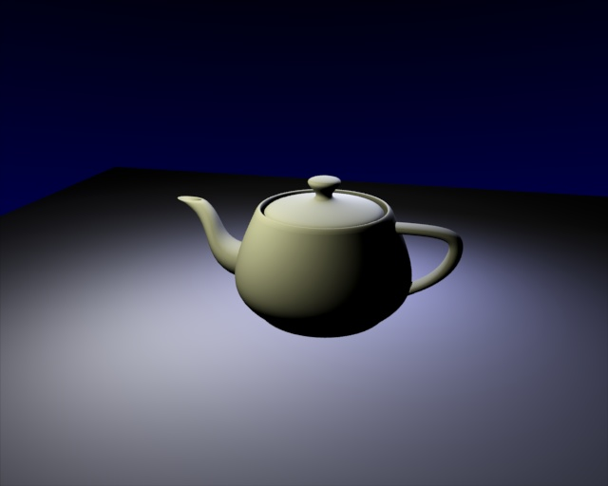  Range: 2.0, Exposure: 0.3.

Hints
Try to find the best Range value, so that overexposed parts are barely not too bright. Now turn up the Exposure value until the overall brightness of the image is satisfying. This is especially useful with area lamps.

